**Section 18) AWS serverless : Dynamo db**

**DynamoDB : is a database that is manage by aws and it is scale for us**

**DynamoDB Overview**

**It is nosql serverless database**

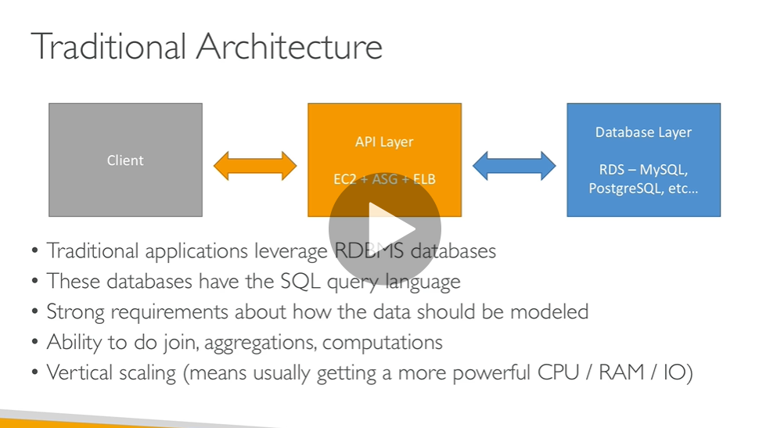

**NoSQL databases** (aka "not only SQL") are non tabular, and store data differently than relational tables. **NoSQL databases** come in a variety of types based on their data model. The main types are document, key-value, wide-column, and graph.

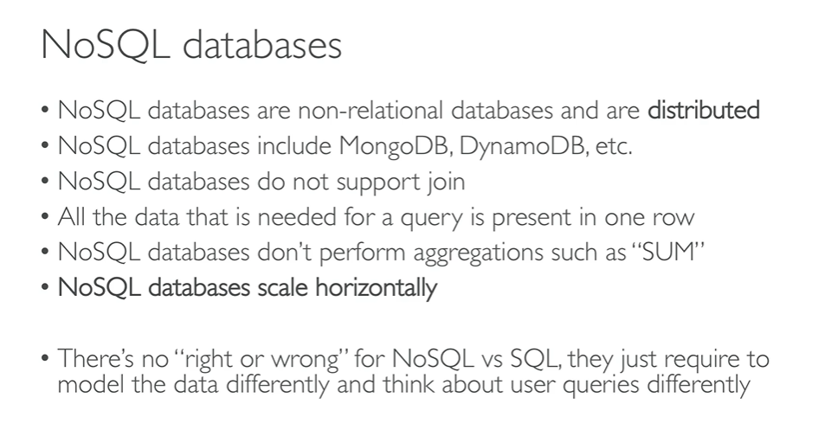

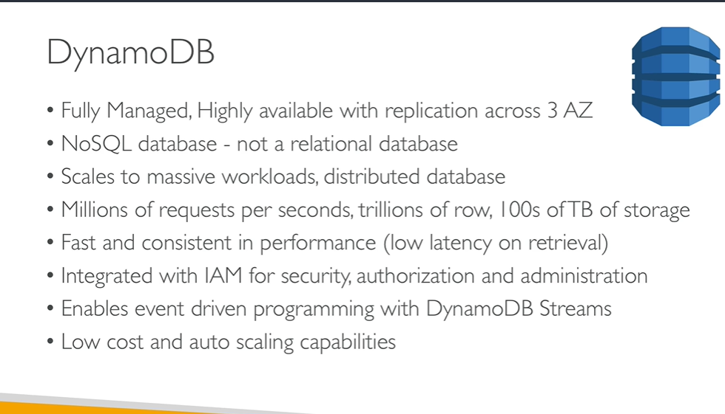

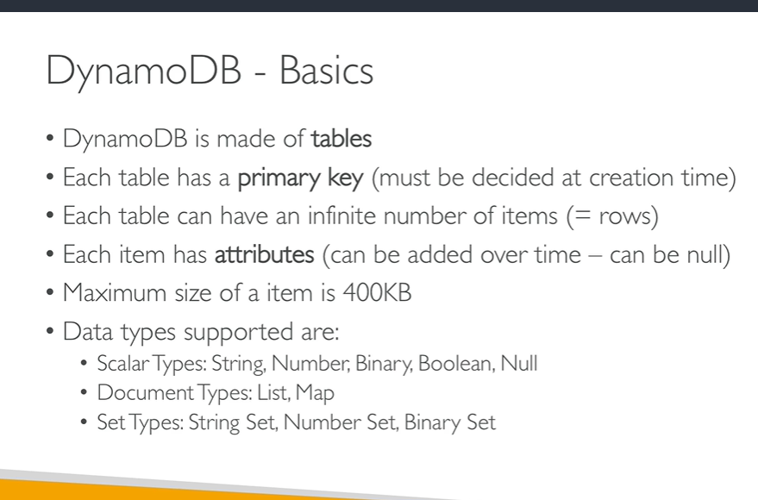

**Traditional table**

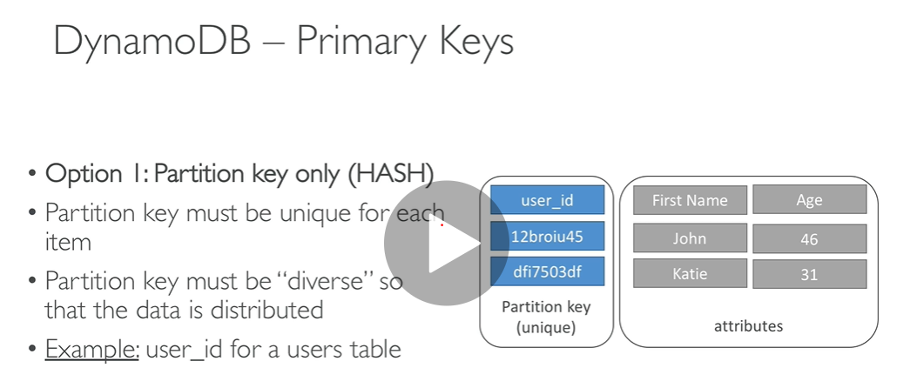

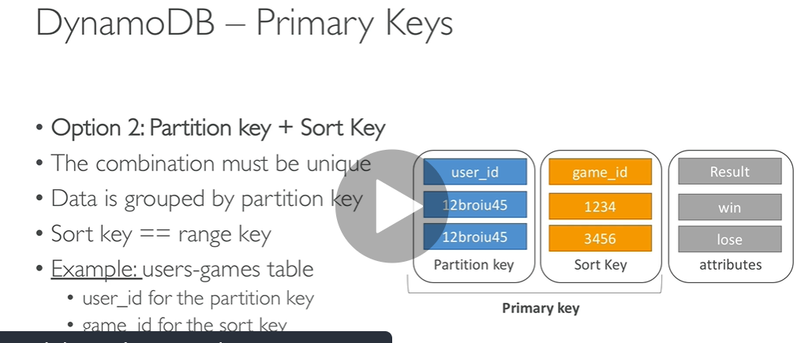

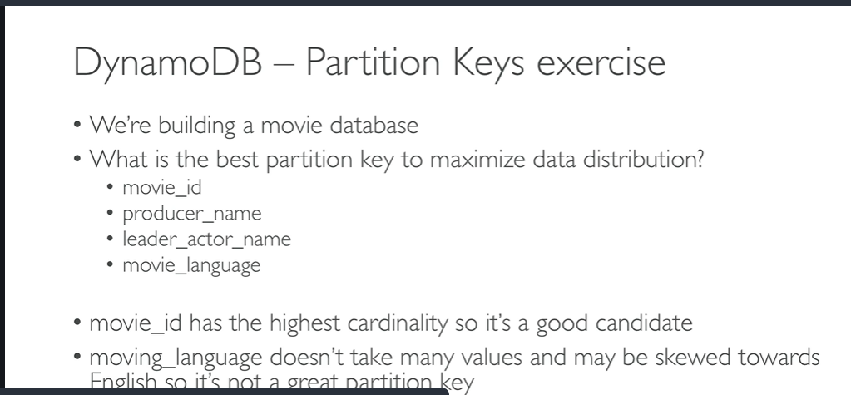

**DynamoDB basics hands on**

**Amazon DynamoDB** is a fast and flexible NoSQL database service for all applications that need consistent, single-digit millisecond latency at any scale. Its flexible data model and reliable performance make it a great fit for mobile, web, gaming, ad-tech, IoT, and many other applications.

**Step1)**

**search DyanamoDB and click create table**

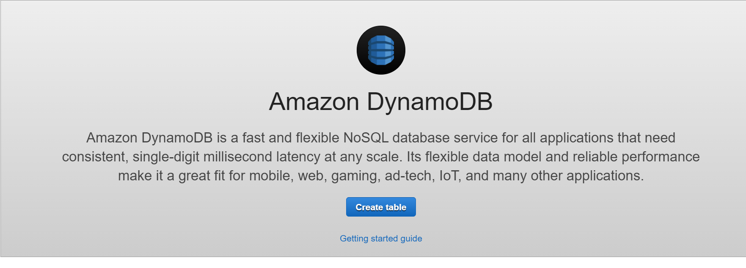

Note :

We don’t need to create database that will be manage by AWS.

We need to create table

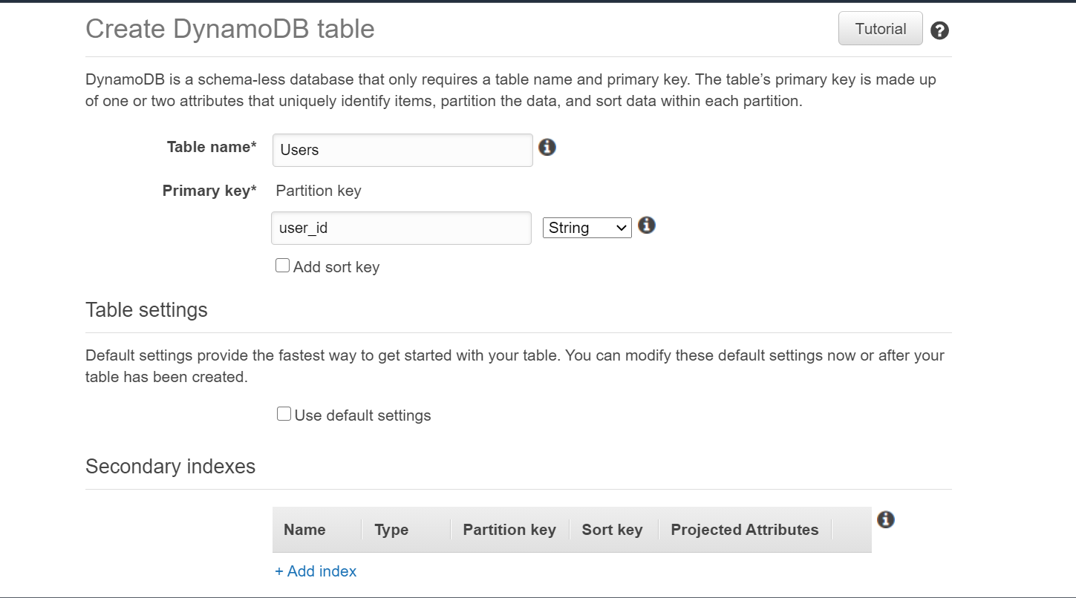

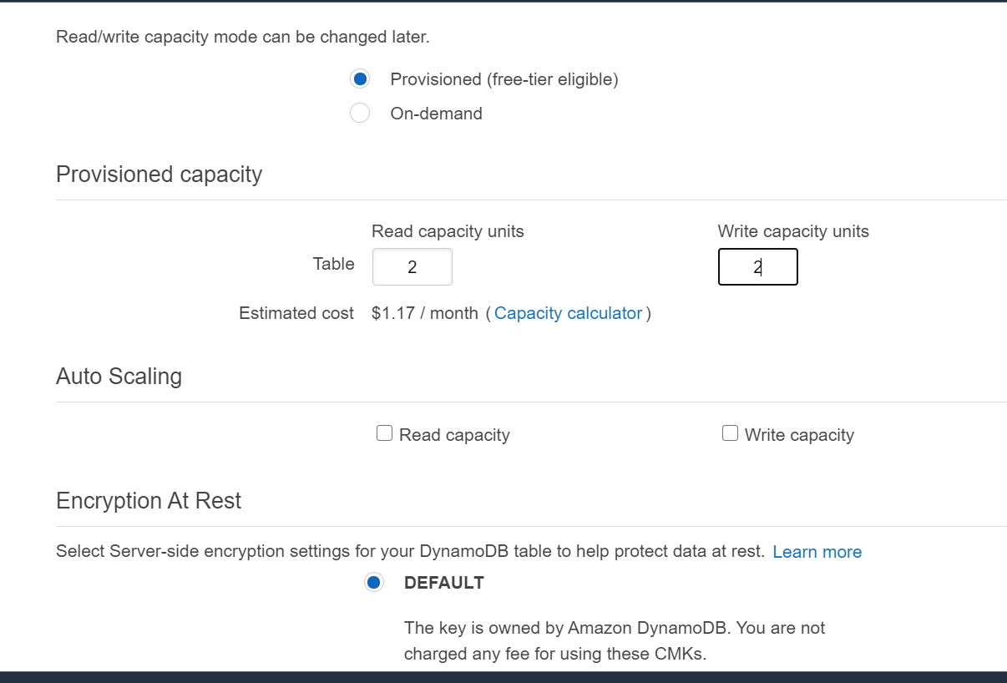

**Click create**

**Table is created and this table will get lot of different tabs**

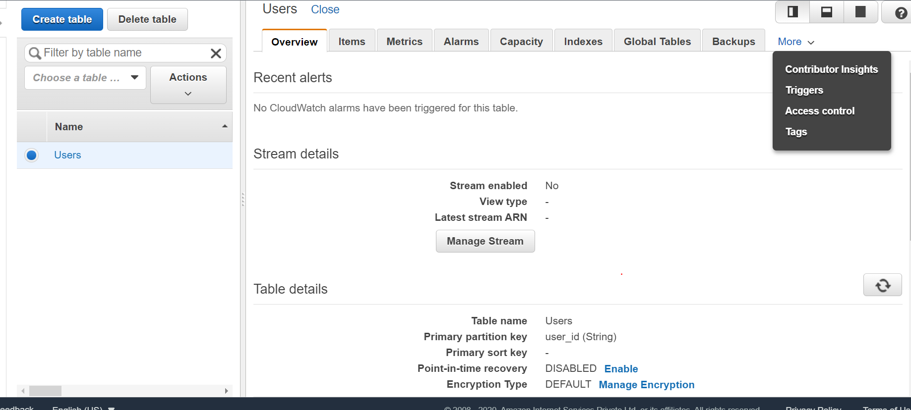

**Note :**

**In items tab we are able to add data in table**

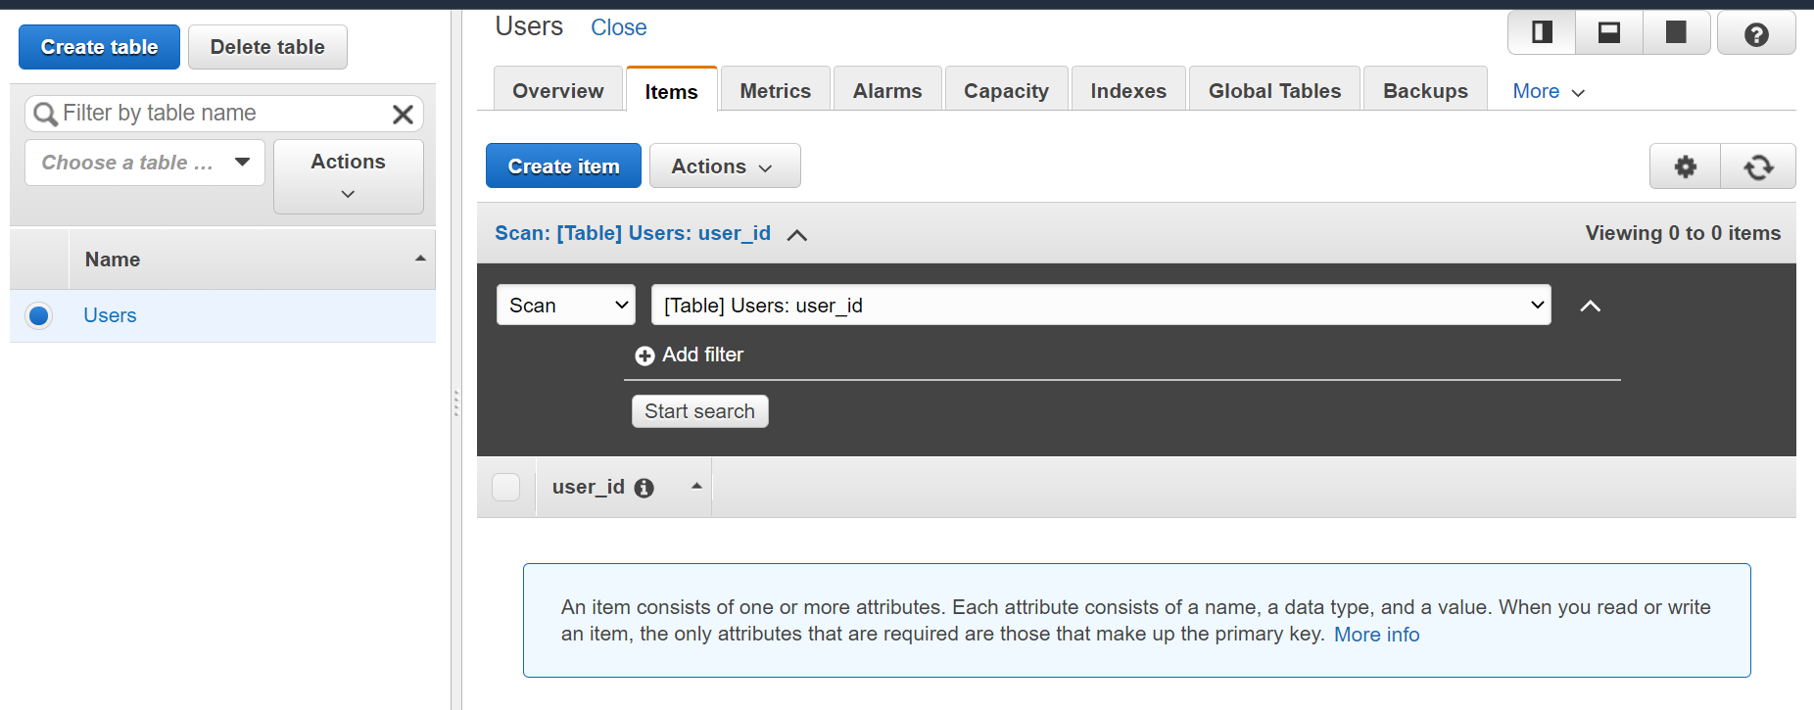

**Click on create item**

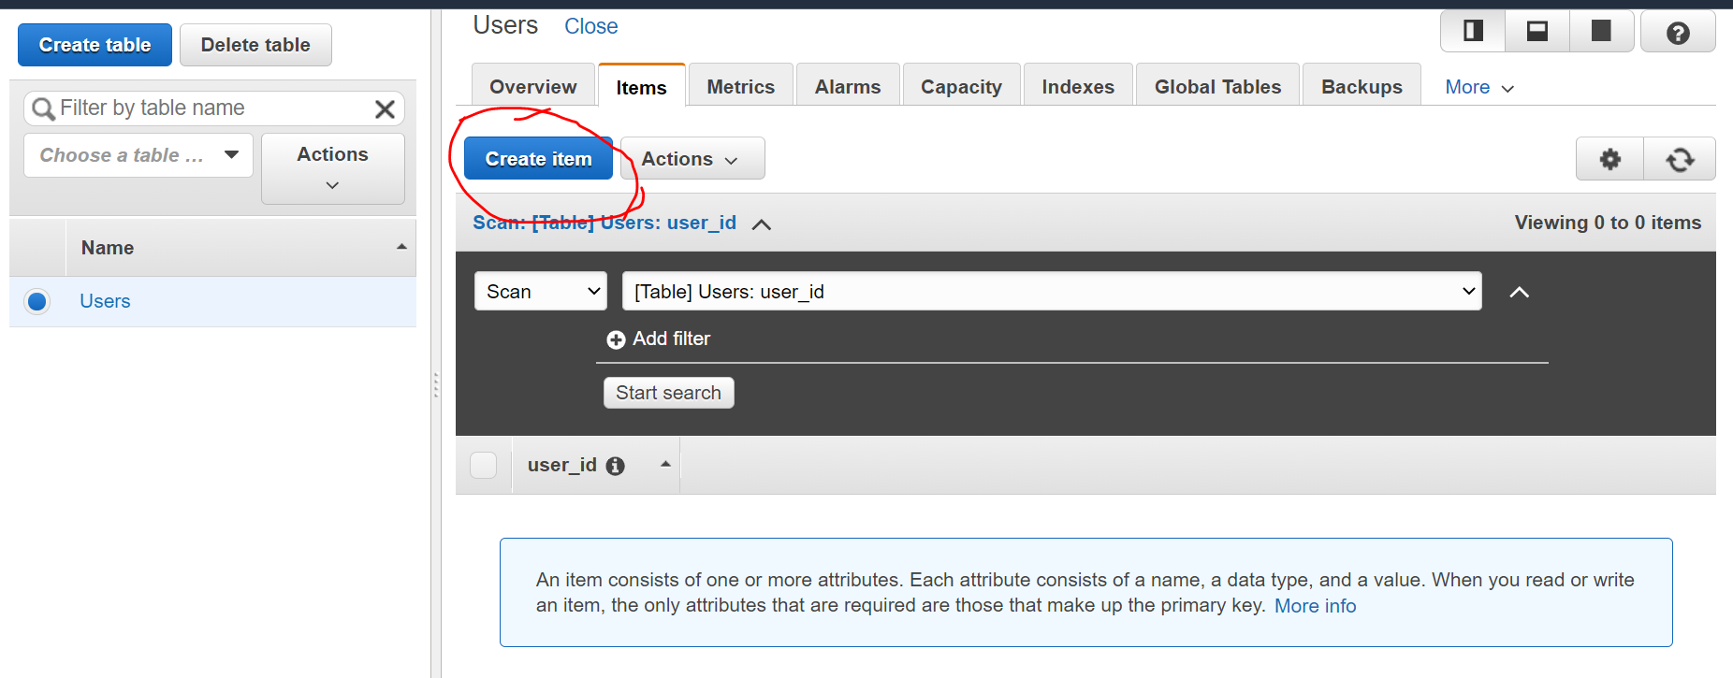

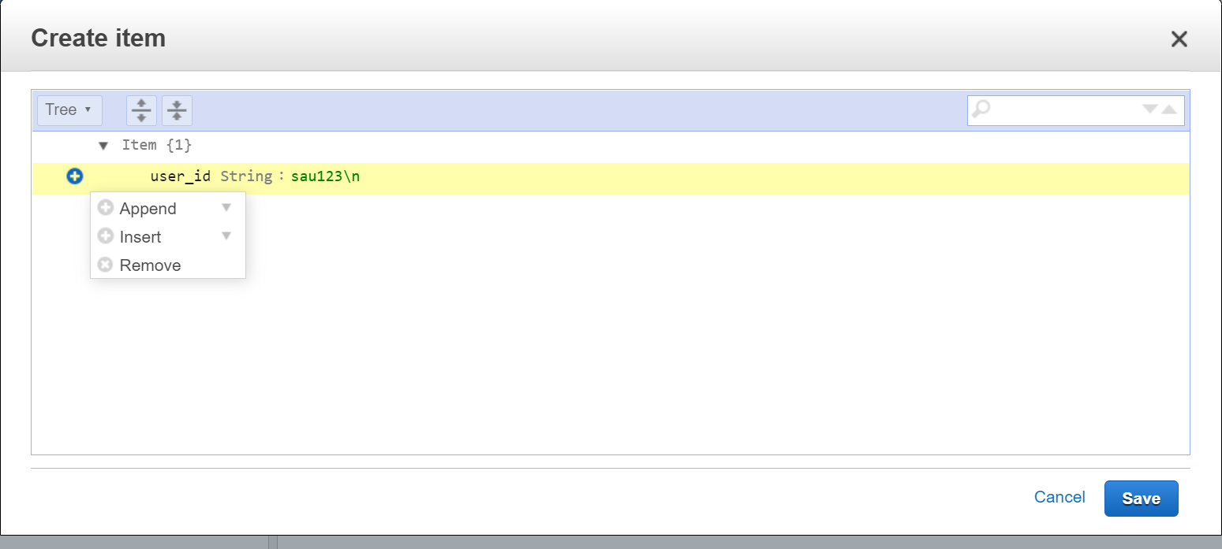

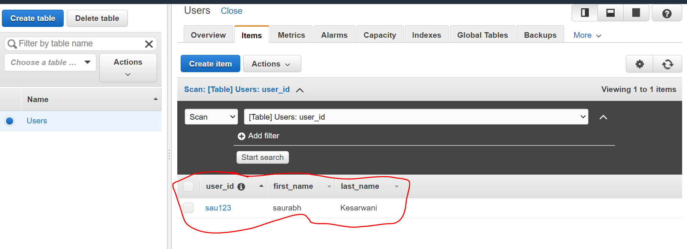

**Note : in dynamoDB it is completely fine any field to be null**

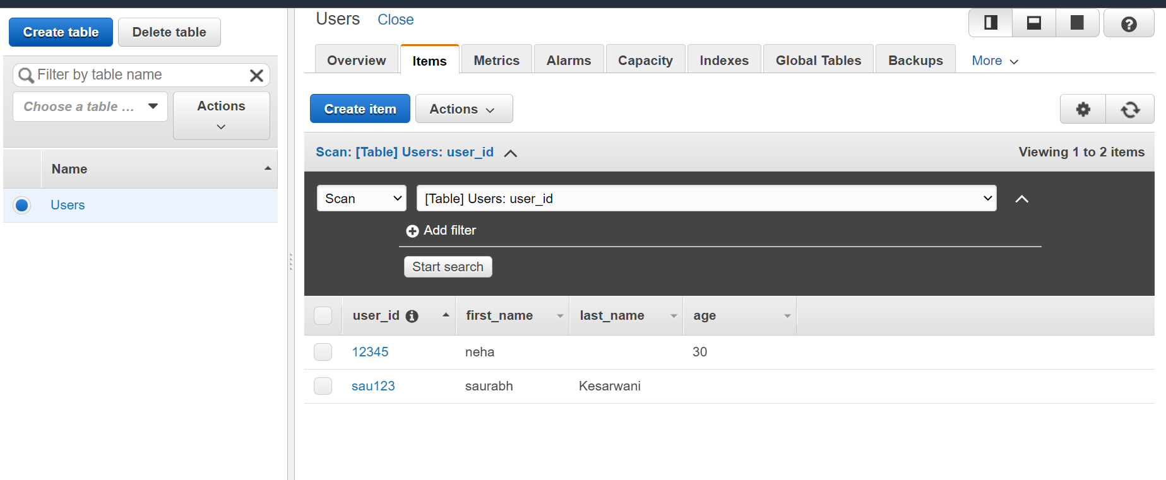

**Create one more table**

**Note the combination of user_id and post_ts is unique**

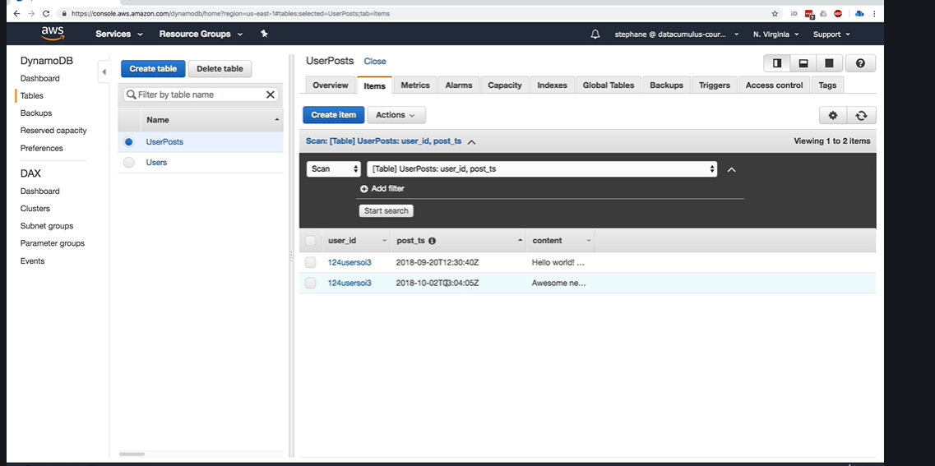

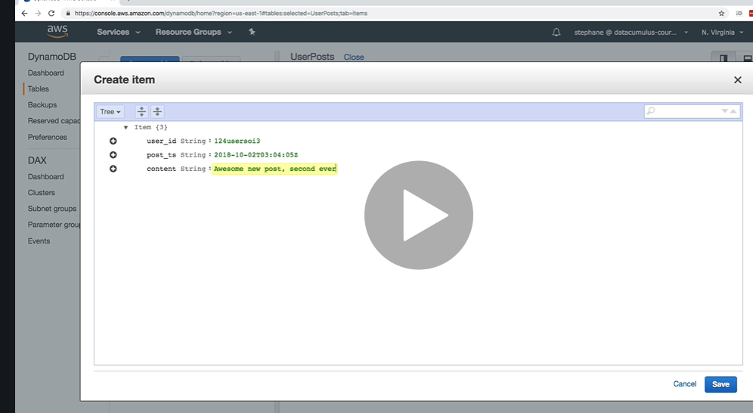

DynamoDB WCU and RCU Throughput

Imp

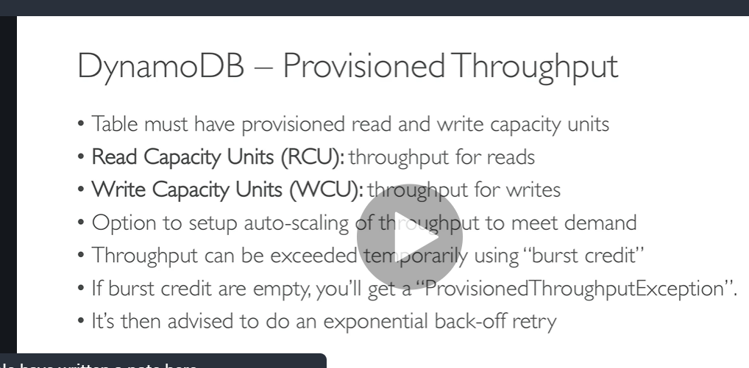

**Imp) forrmula )Find wcu ----per second----one wcu===1 kb**

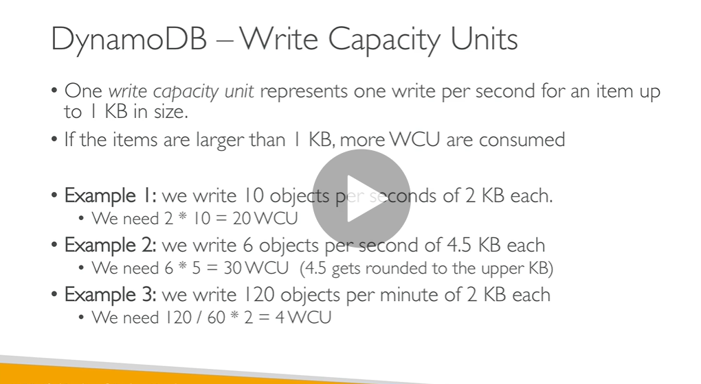

**Note ) read occur from dynamoDB before replication from application then we are in eventually consistent read state**

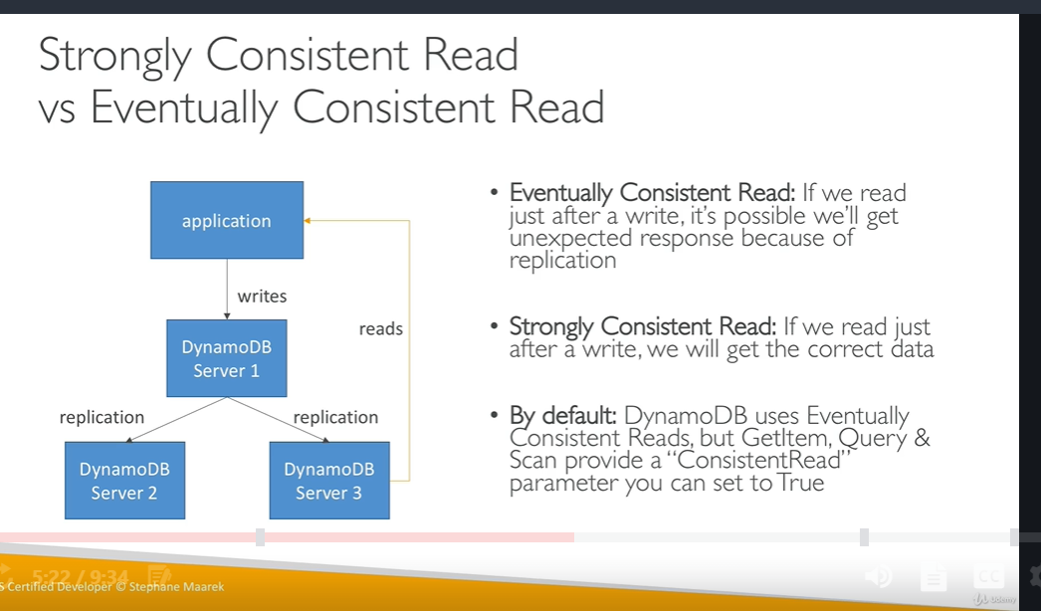

**Formula for RCU :=------per second / 4kb in size**

**Strongly consistent read---1**

**Eventually consistent read---2**

**Note : need to round of**

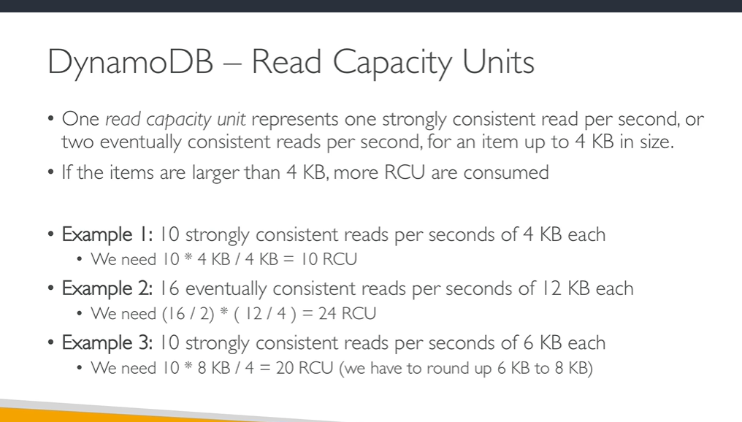

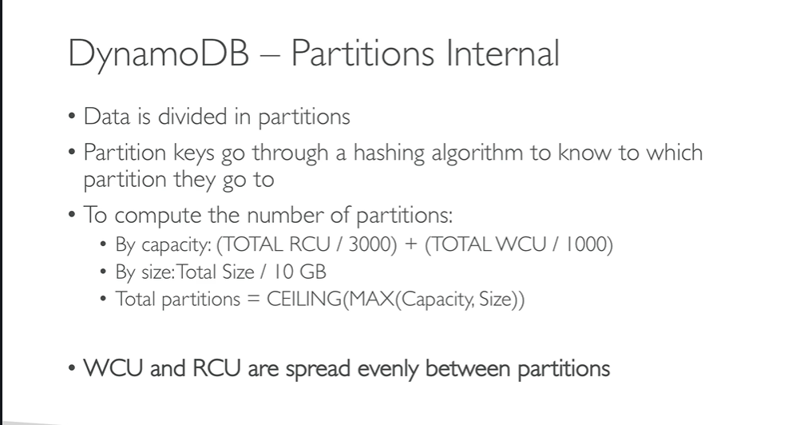

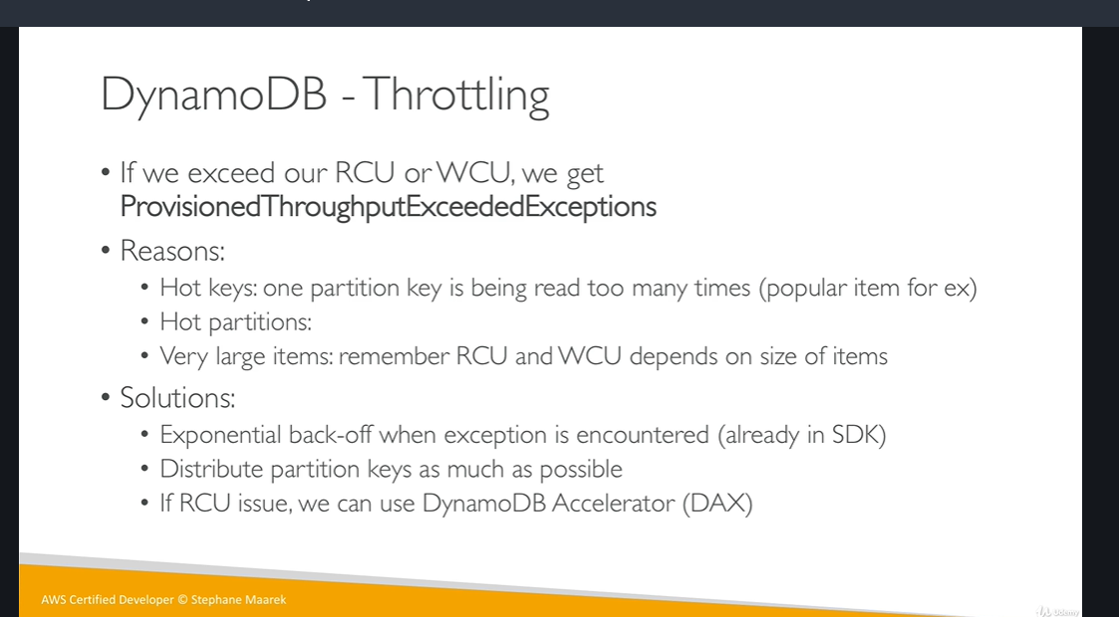

Amazon **DynamoDB** Accelerator (**DAX**) is a fully managed, highly available, in-memory cache for Amazon **DynamoDB** that delivers up to a 10 times performance improvement—from milliseconds to microseconds—even at millions of requests per second.

DynamoDB WCU and RCU hands on

Note

We can do practist in capacity calculator

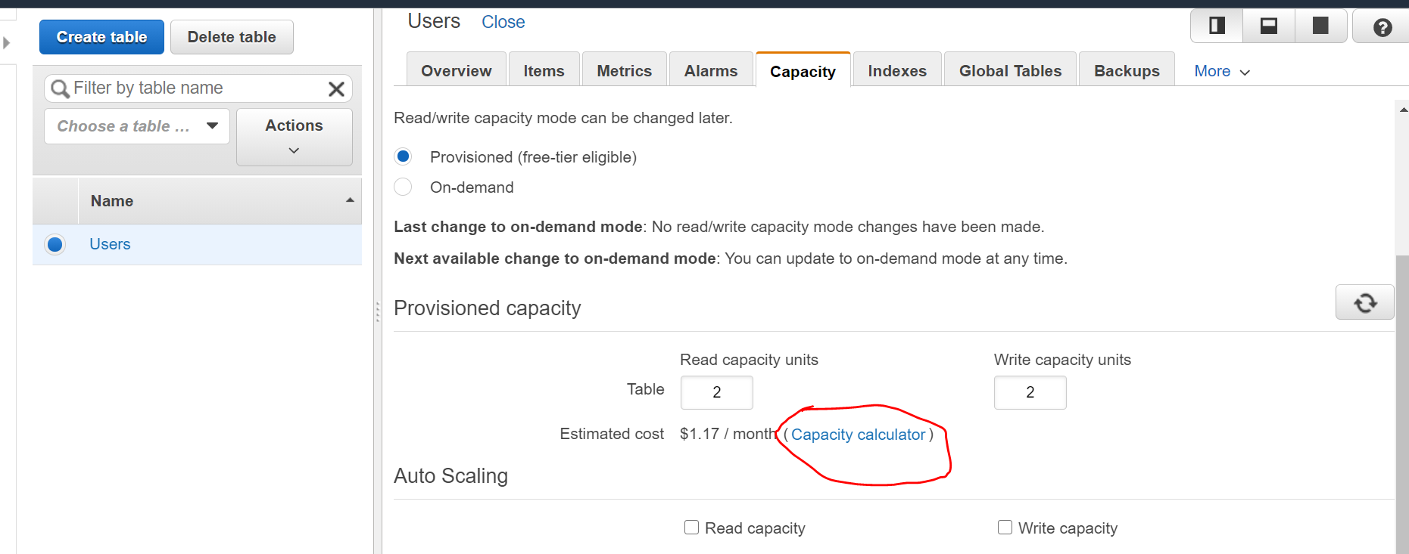

**Note:**

**We can enable autoscaling to match load for dynamoDB table**

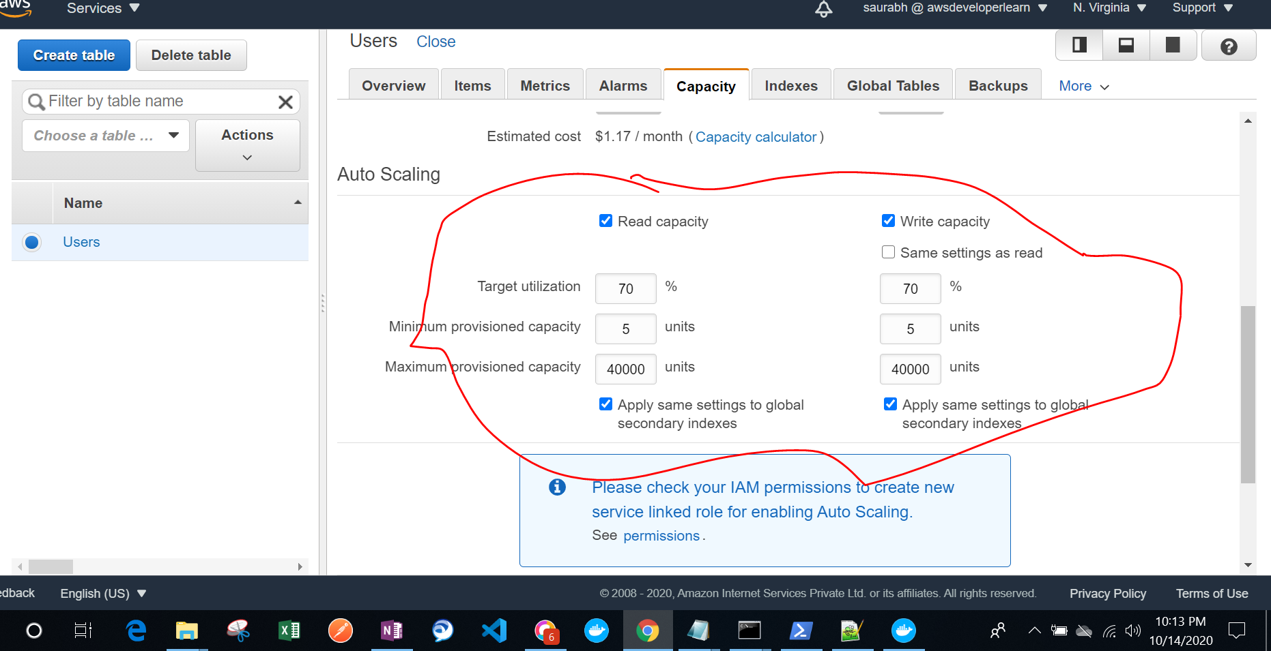

**DynamoDB basics API**

**Conditional writes-----concurrency (remember)**

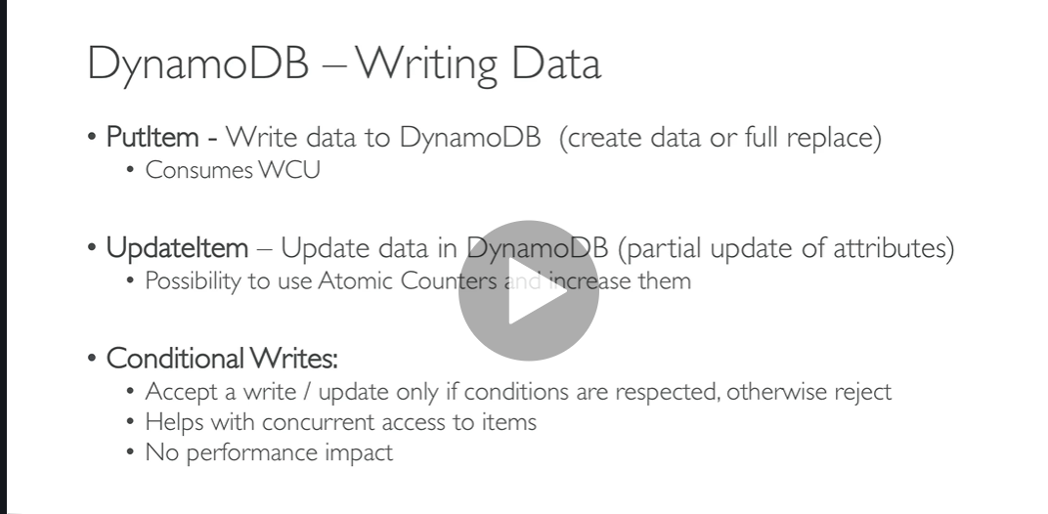

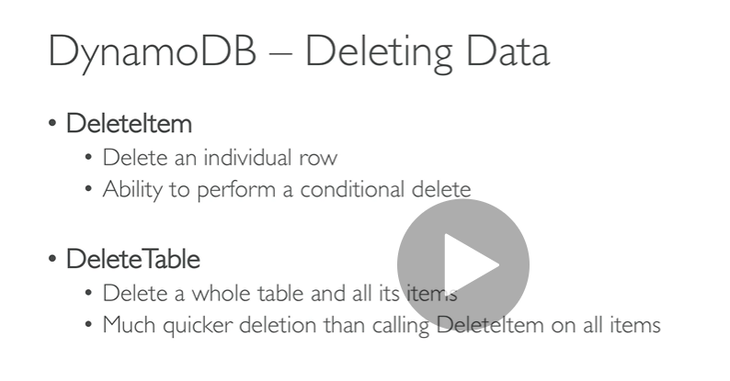

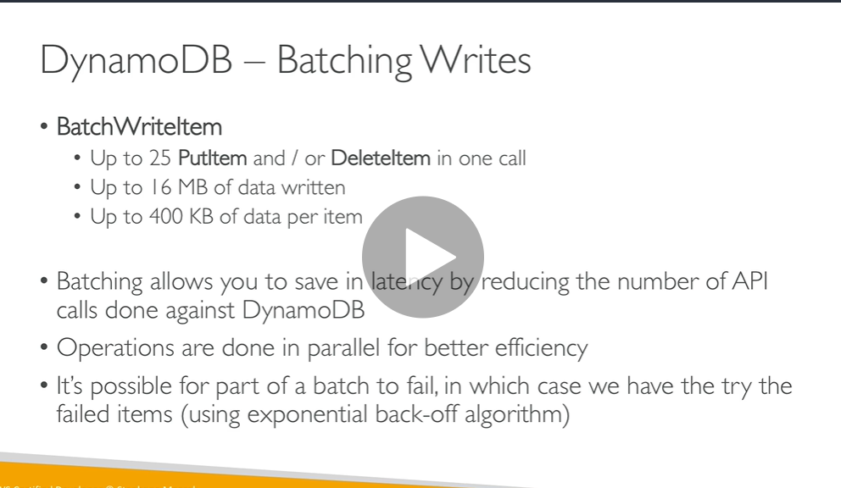

In addition to simple retries, each **AWS** SDK implements **exponential backoff** algorithm for better flow control. The idea behind **exponential backoff** is to use progressively longer waits between retries for consecutive error responses. You should implement a maximum delay interval, as well as a maximum number of retries.

**Note : strongly consistent read take twice RCU as eventually consistent read**

**Projectionexpression use to get certain attribute**

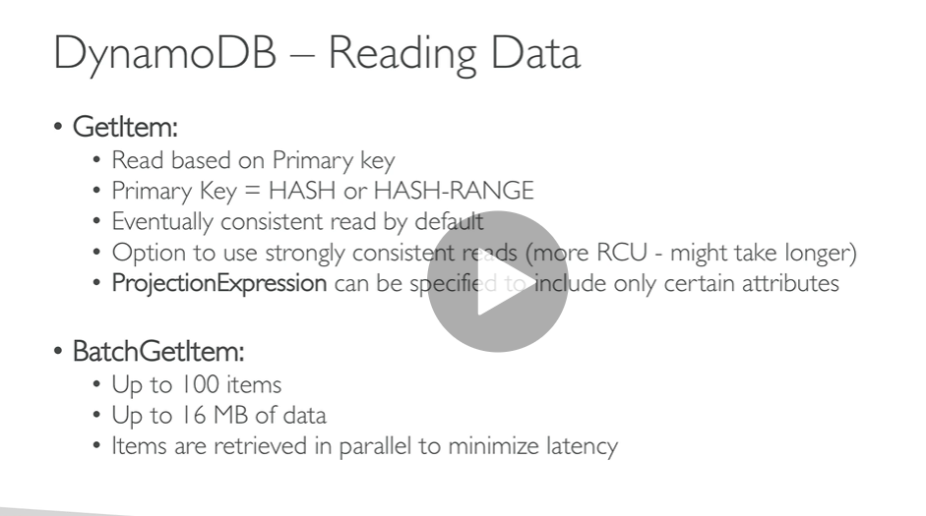

**Note : filter happens on client side**

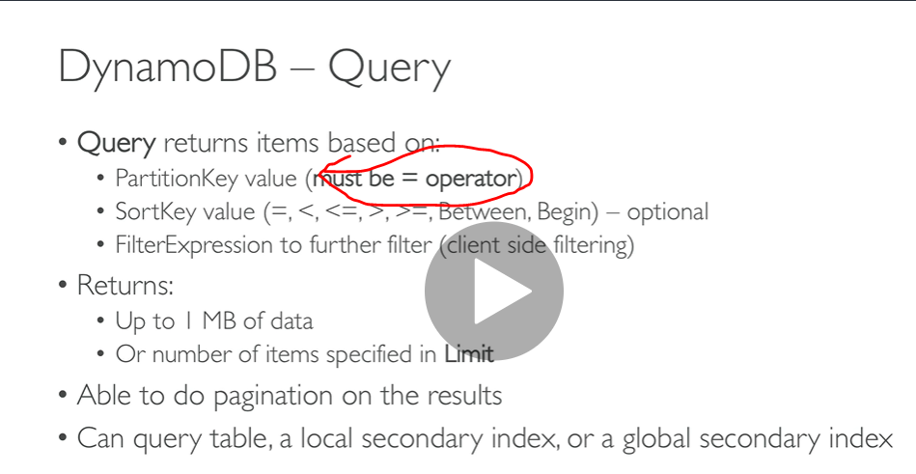

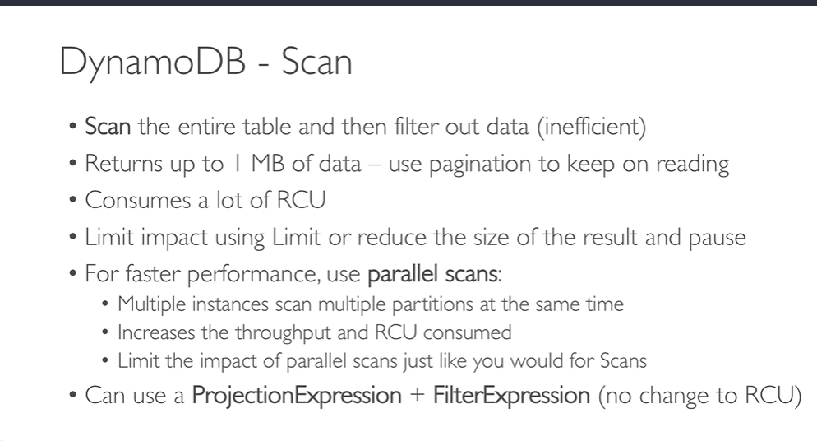

**DynamoDB basics api hands on**

**Note:**

**Query has to be =**

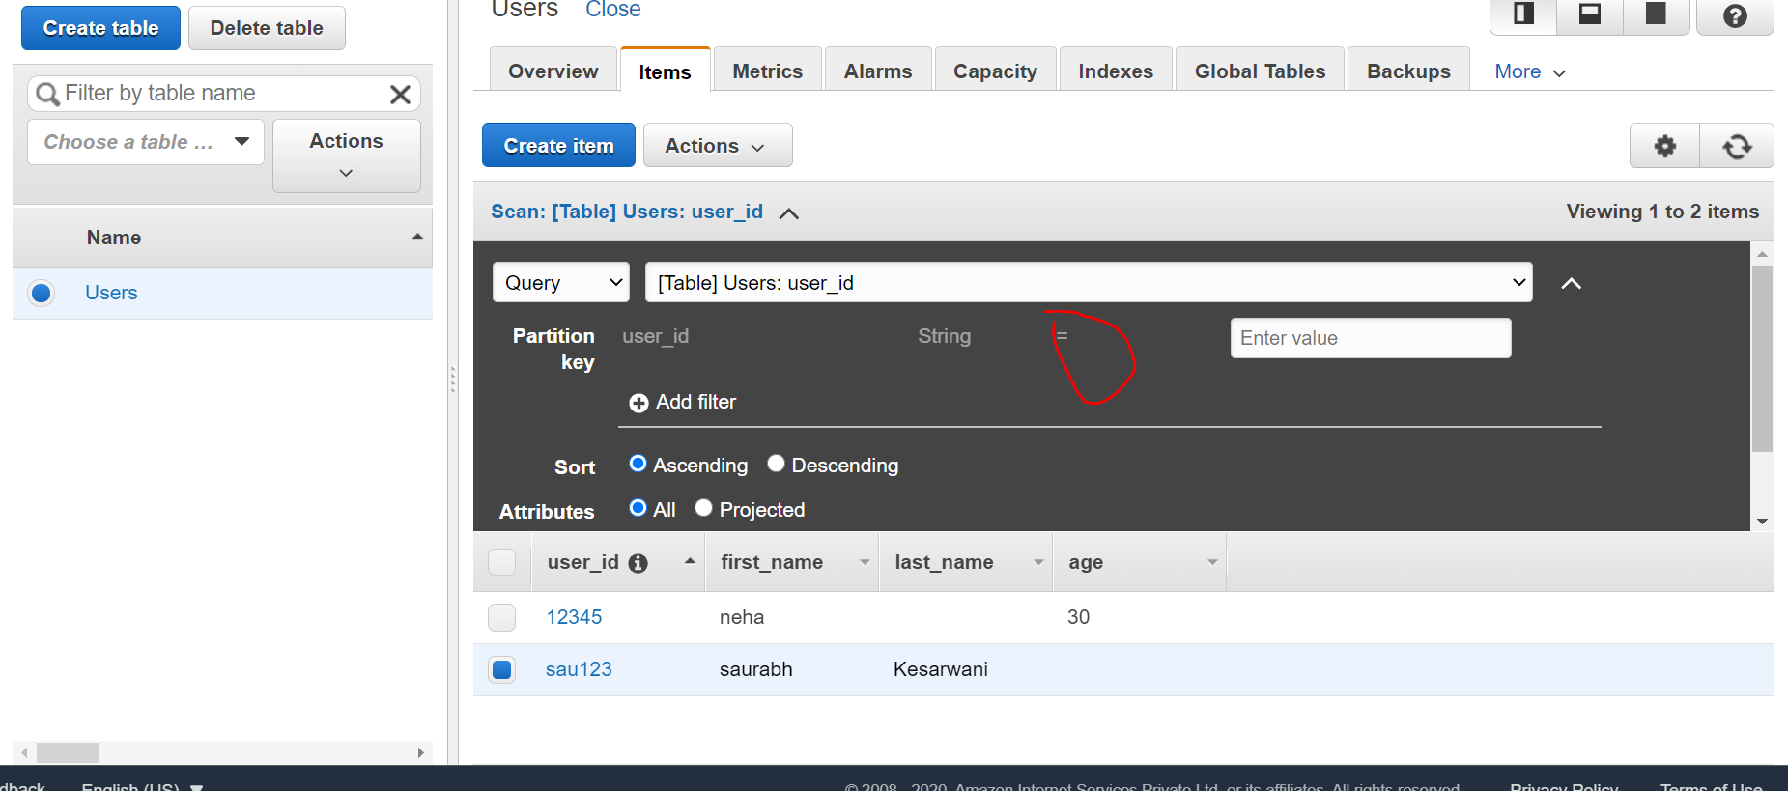

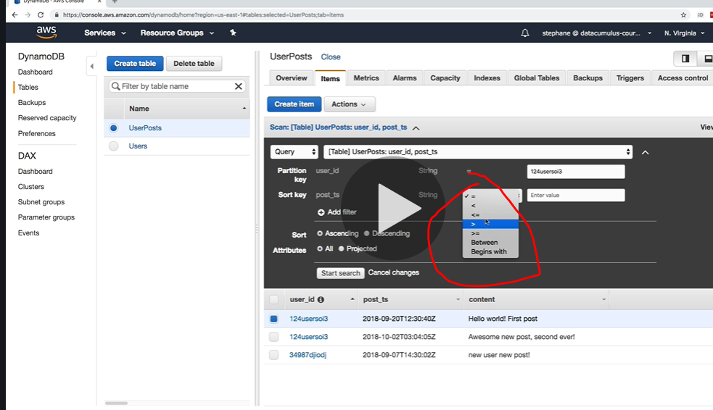

**DynamoDB Indexes (GSI + LSI)**

**GSI( global secondary indexes)**

**LSI(local secondary indexes)**

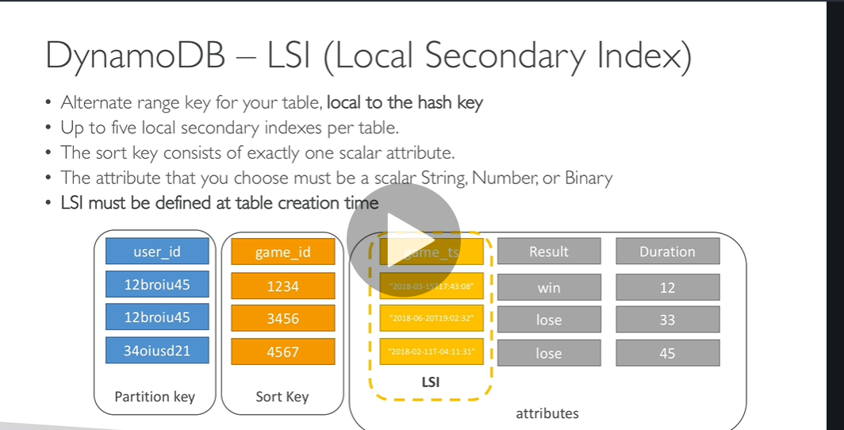

A **Local Secondary Index** (**LSI**) has the same partition key as the primary key (index), but a different range key. The way to think about an **LSI** is that its the same data as the primary index (key), just ordered by a different attribute

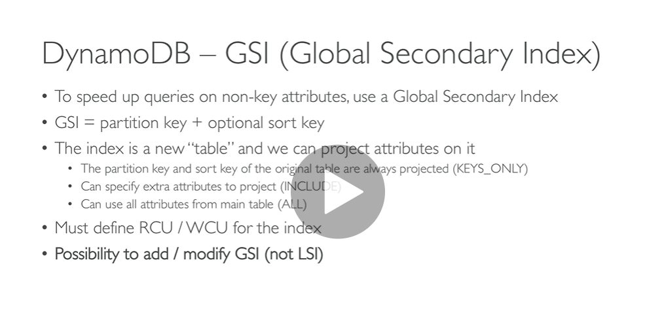

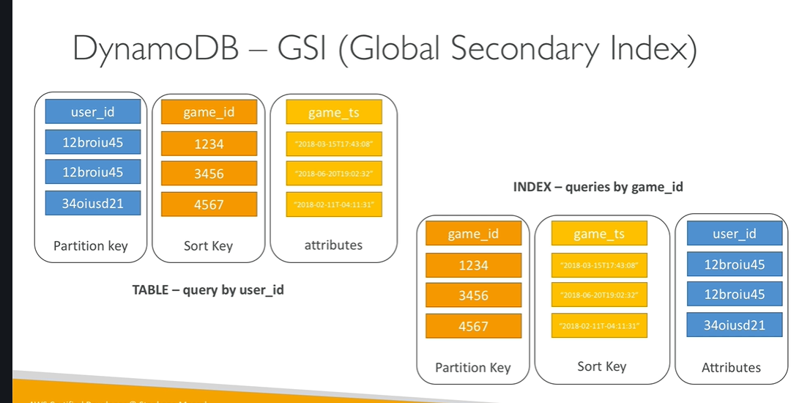

**Note : by defining global index we can perform more efficient type of query**

**LSI is local to partition key whereas GSI is whole new different table**

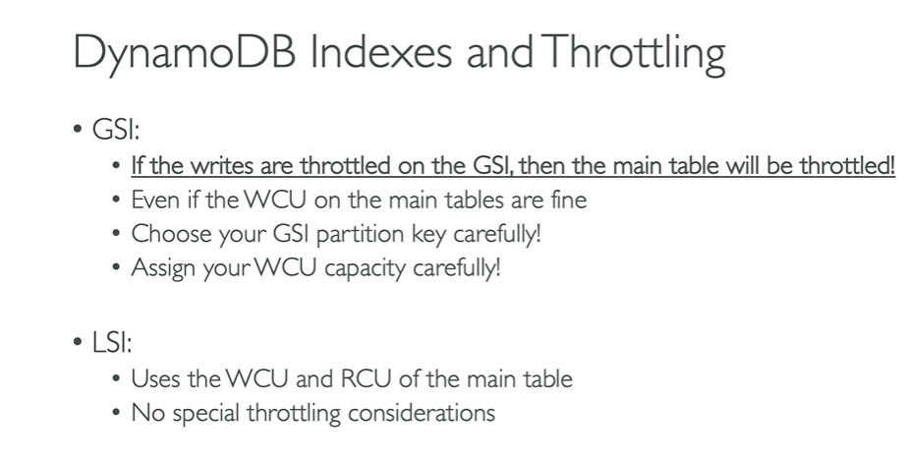

**Hands on**

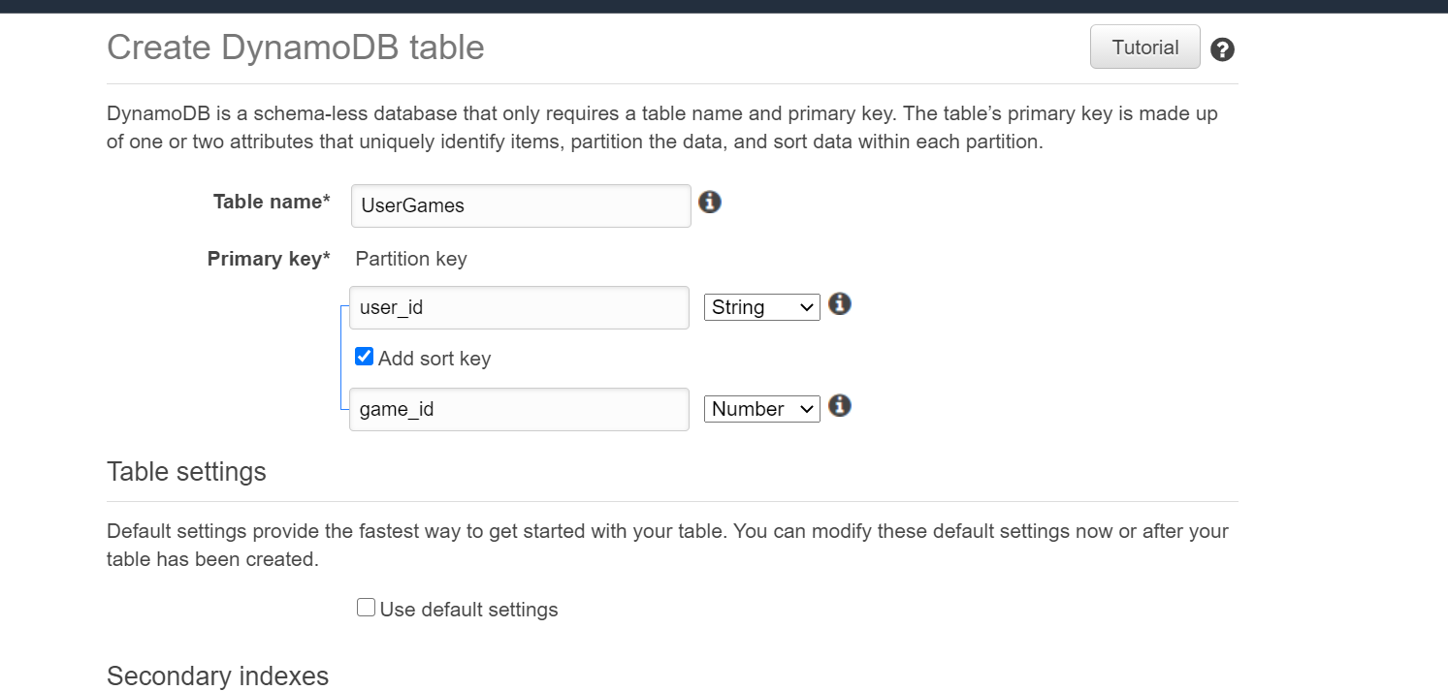

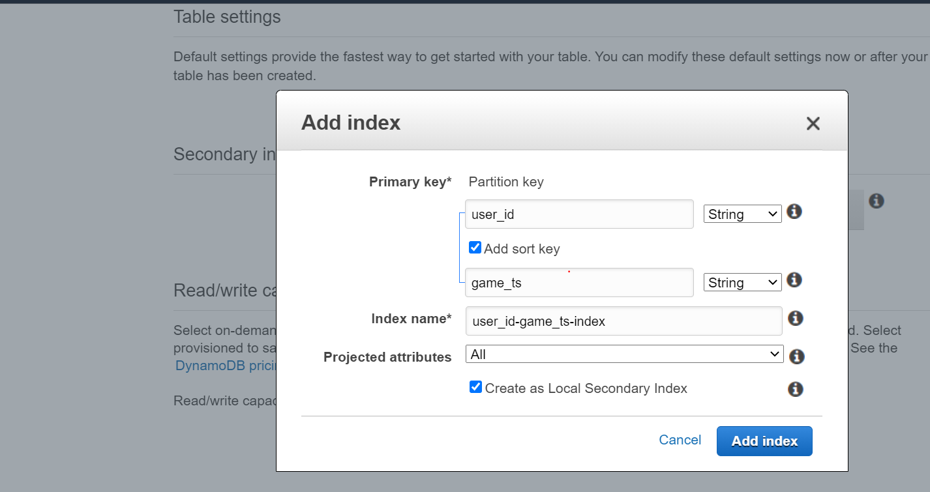

**LSI will create at the time of table creation**

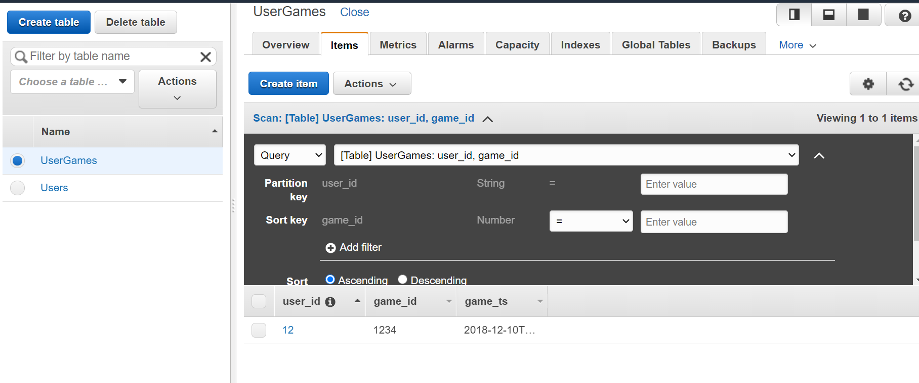

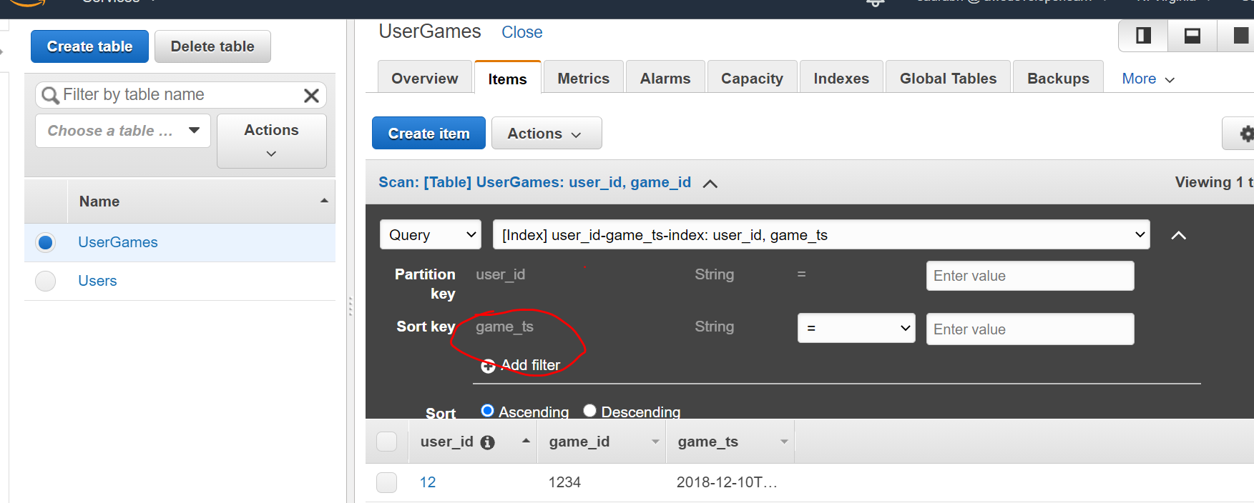

**DynamoDB Optimistic Concurrency**

**Note :**

**DynamoDB :--- Optimistic locking**

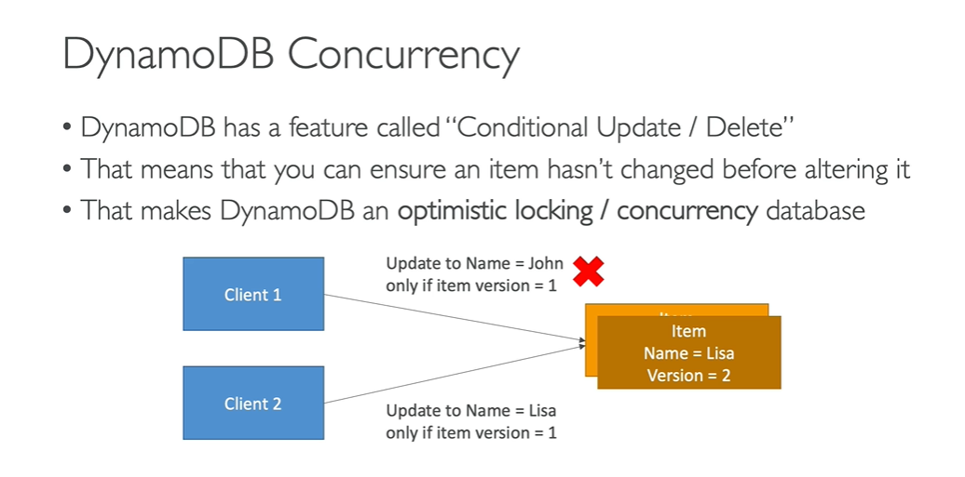

**DynamoDB DAX (DynamoDB accelerator)**

**Caching for DynamoDB**

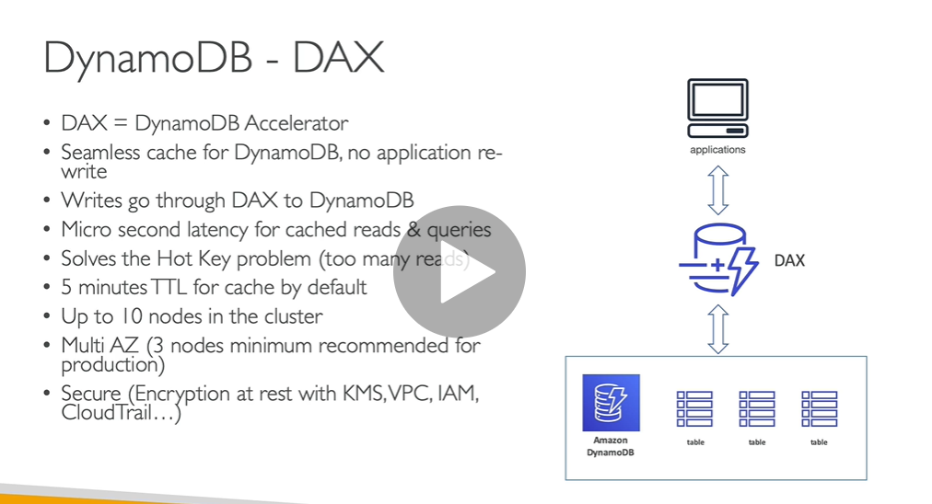

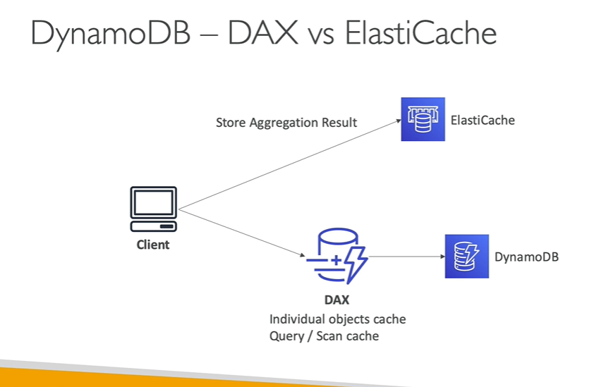

**Hands on:)**

**Step 1 :) click on DAX**

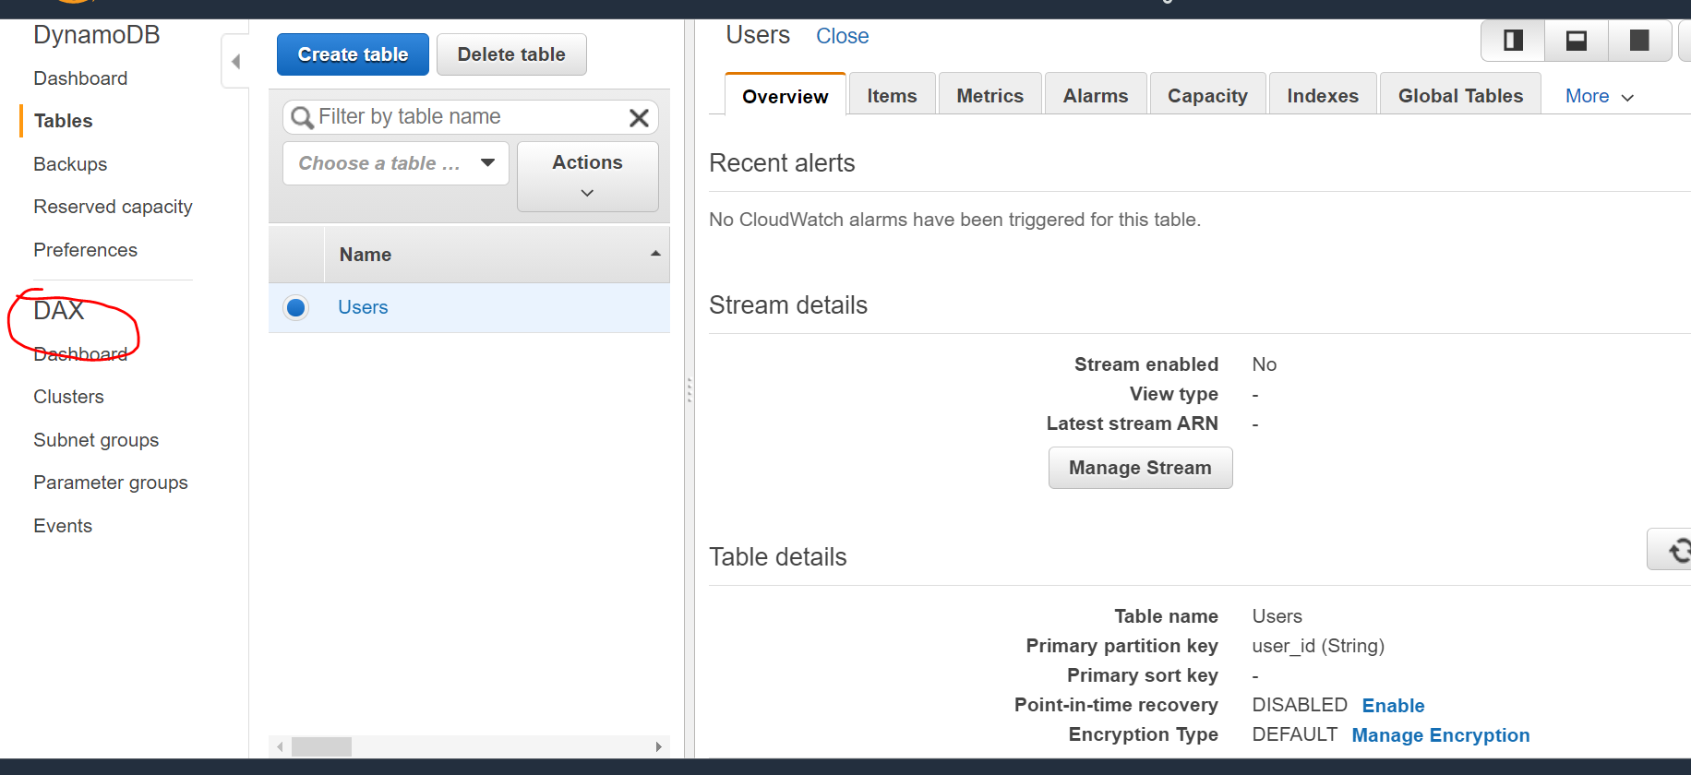

**First create DAX cluster ( it is not free)**

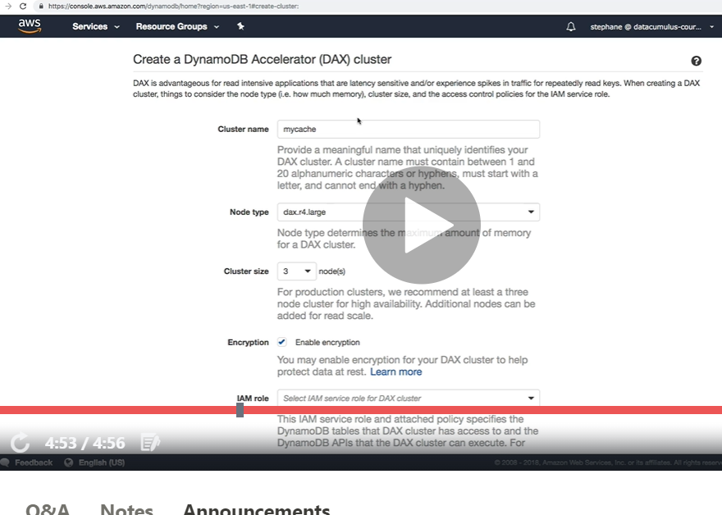

**DynamoDB Streams**

**DynamoDB Streams** is a powerful service that you can combine with other AWS services to solve many similar problems. When enabled, **DynamoDB Streams** captures a time-ordered sequence of item-level modifications in a **DynamoDB** table and durably stores the information for up to 24 hours.

**DynamoDB stream represent change log of things happen in table( read,update,delete)**

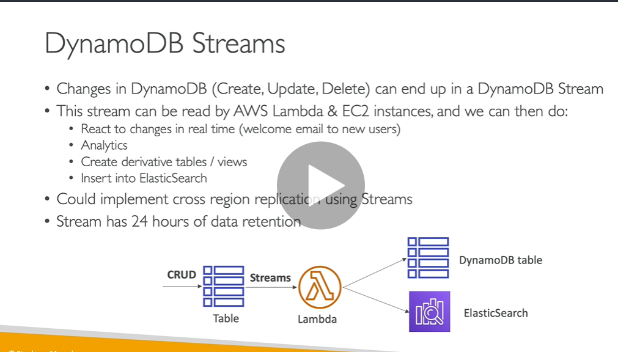

**Previous changes will not effect in stream once we active stream**

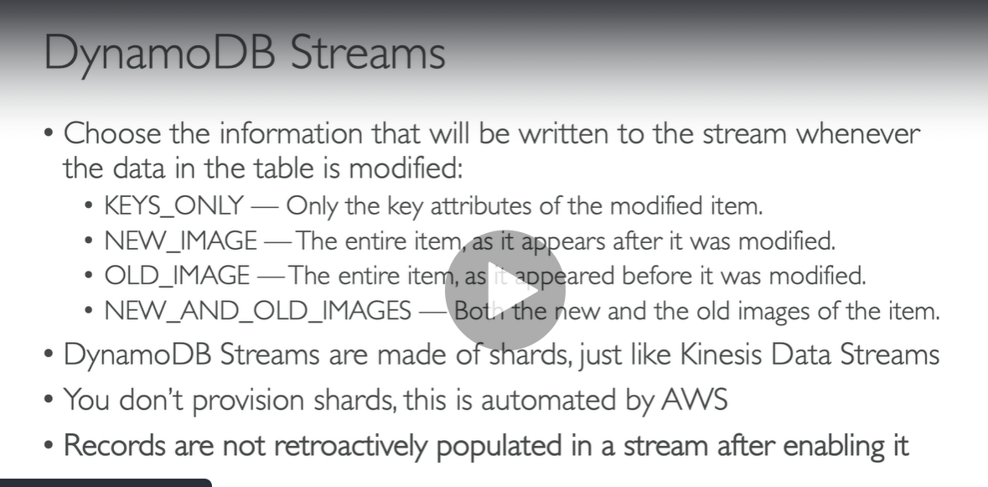

. An **event source mapping** is an AWS Lambda resource that reads from an **event source** and invokes a Lambda function

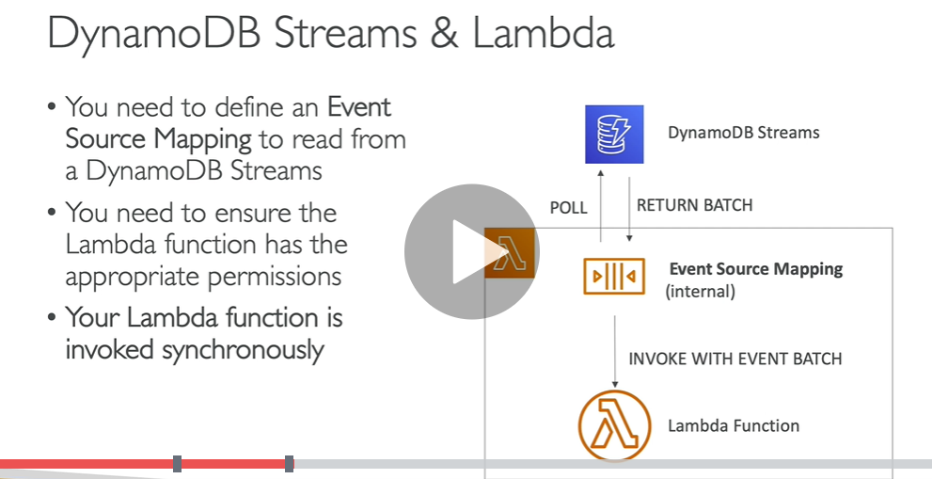

**Hands on**

**First create stream/ trigger/ function which will read from stream**

**Step 1) go to UserGame table and click on manage stream**

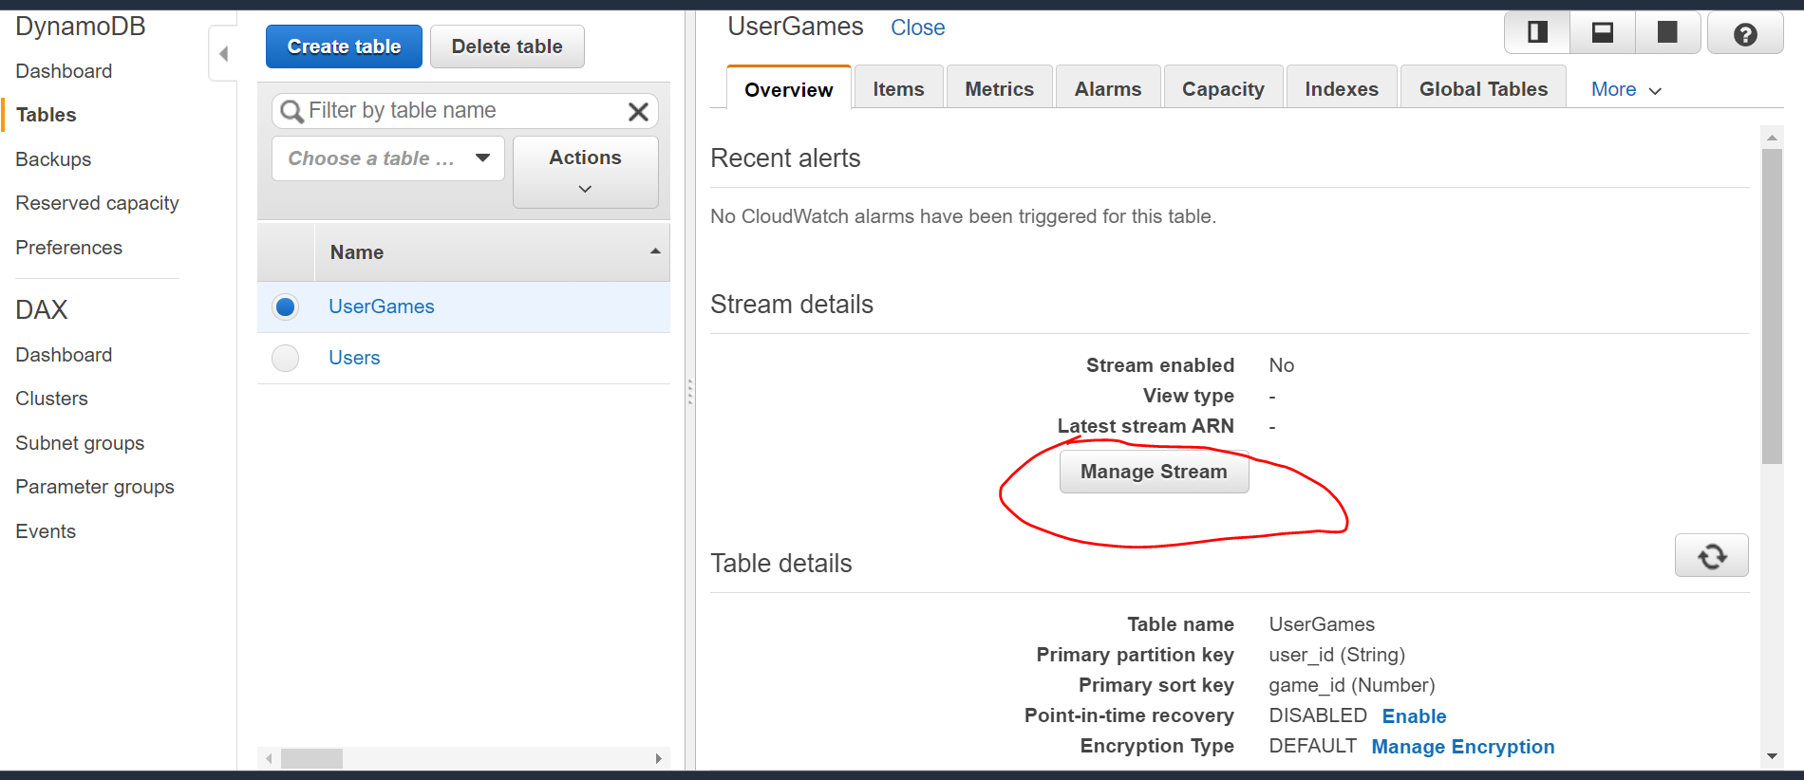

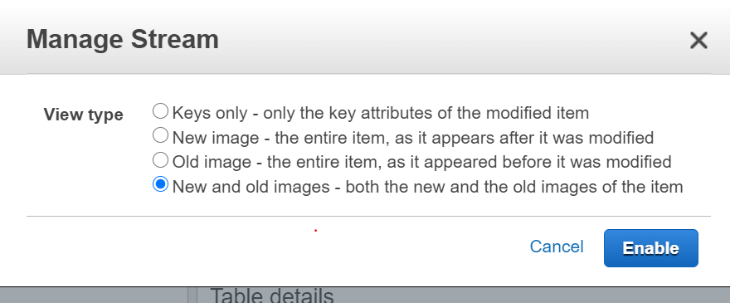

**Now stream is enabled but we need to read from stream for this there is dynamoDB trigger which is using DynamoDB stream**

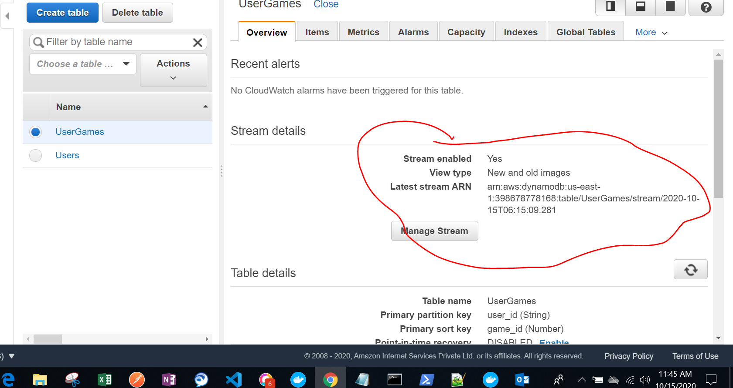

**Click on Trigger**

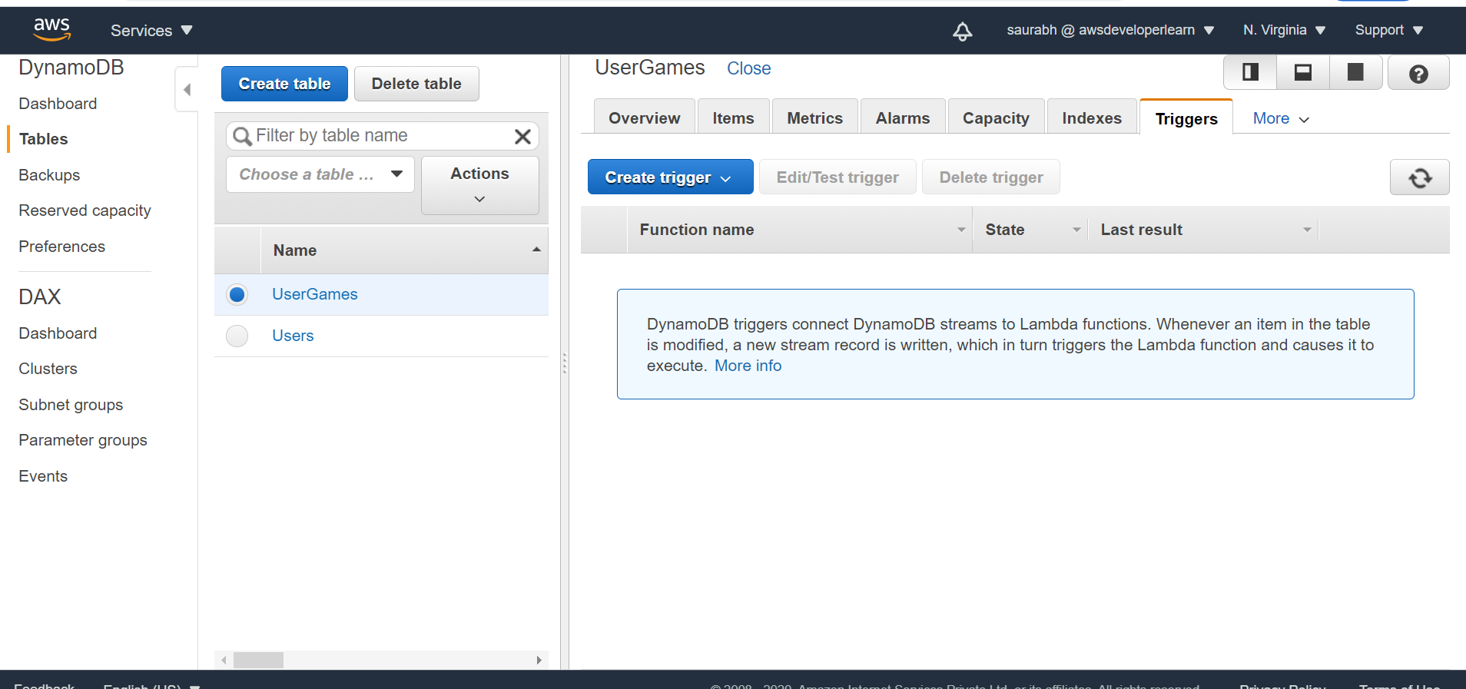

**Click on new function**

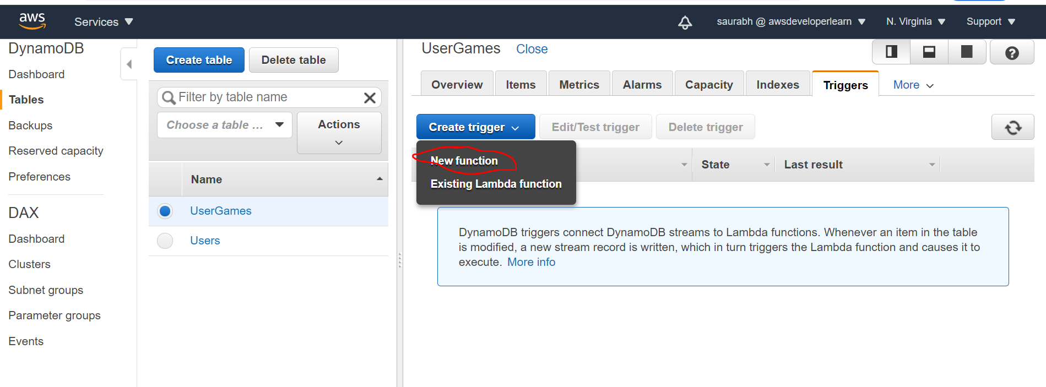

**This function will process dynamoDB stream**

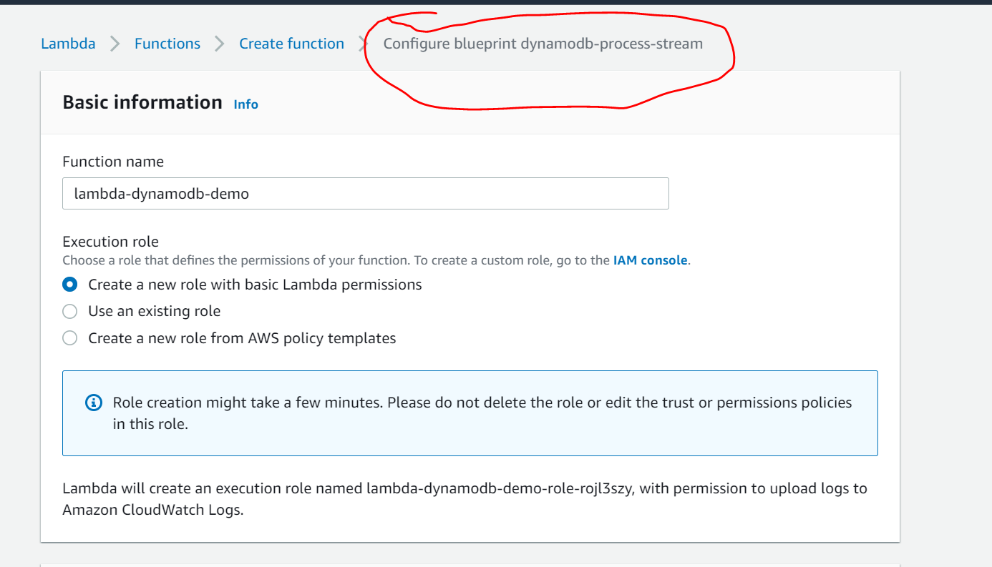

**Trim horizon : read form starting**

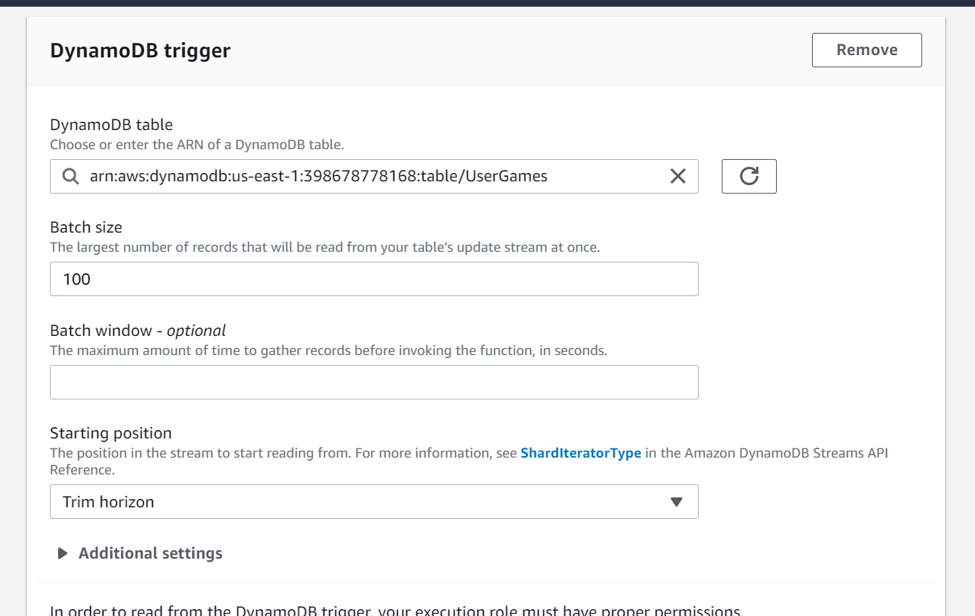

**Very simple function that will log our dynamo db log into cloudwatch logs**

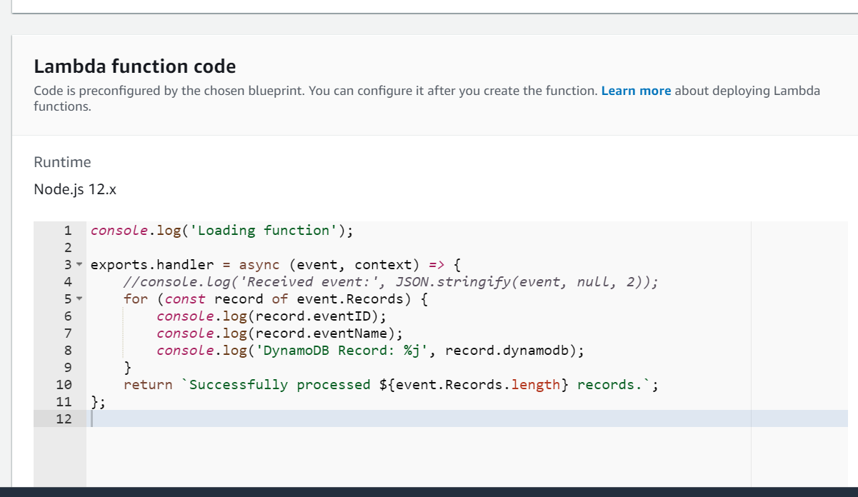

**Click on create function**

**We are getting an error since IAM role is not correct so we need to set it**

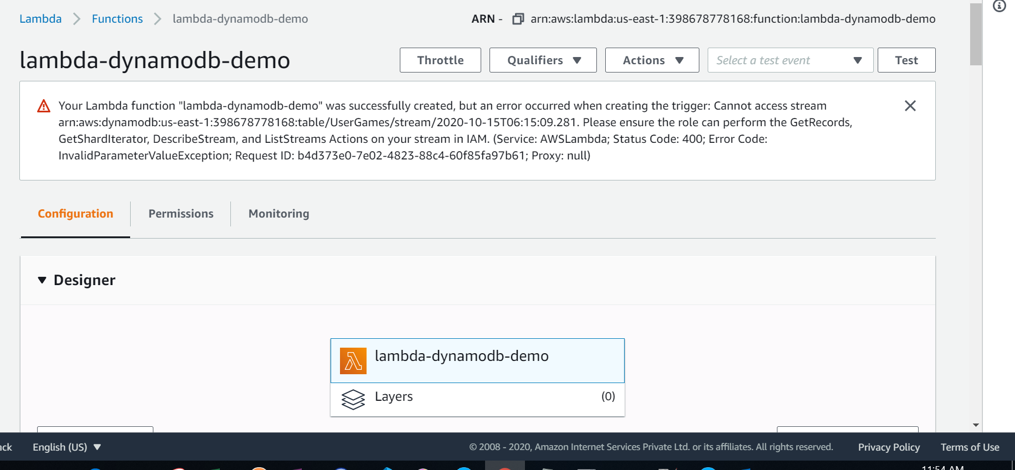

**Go to permission and click it**

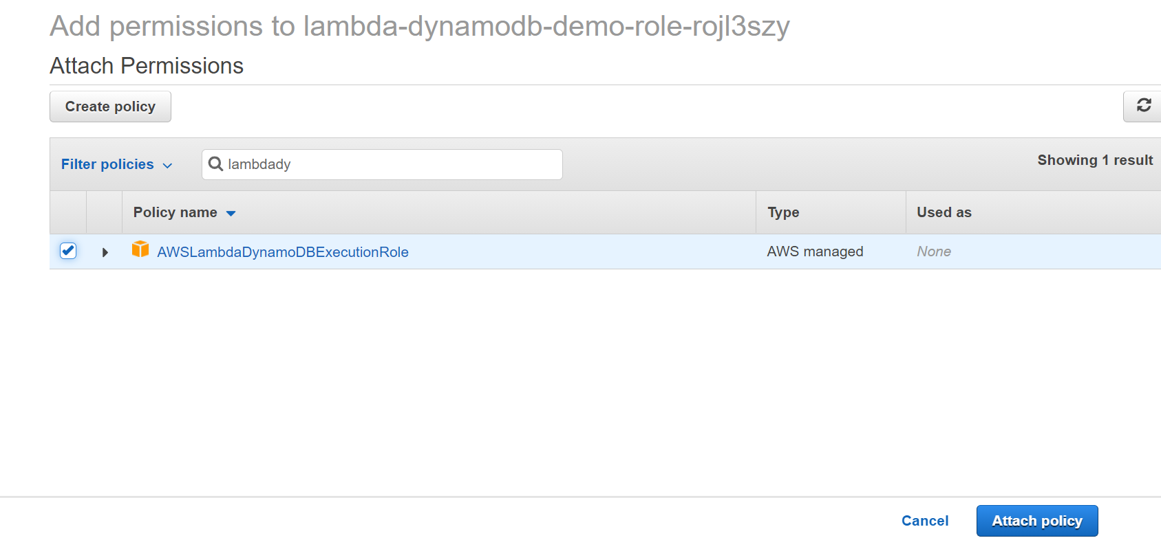

**Policy has been attached**

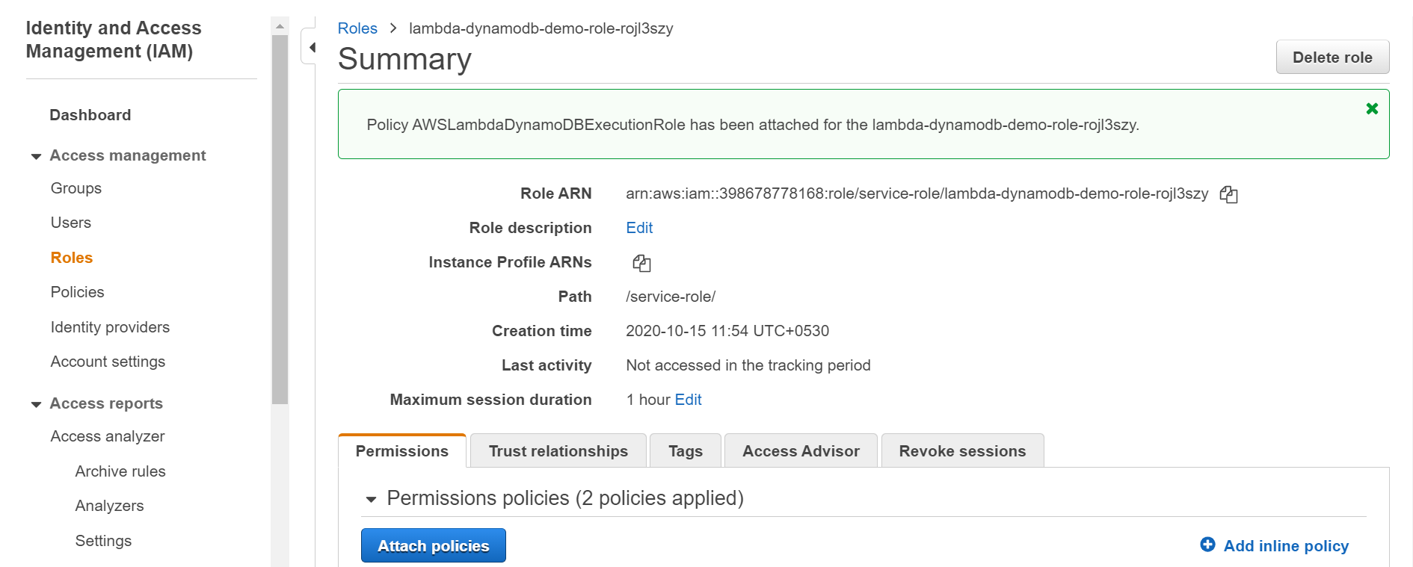

**Now we have access to logs and dynamodb**

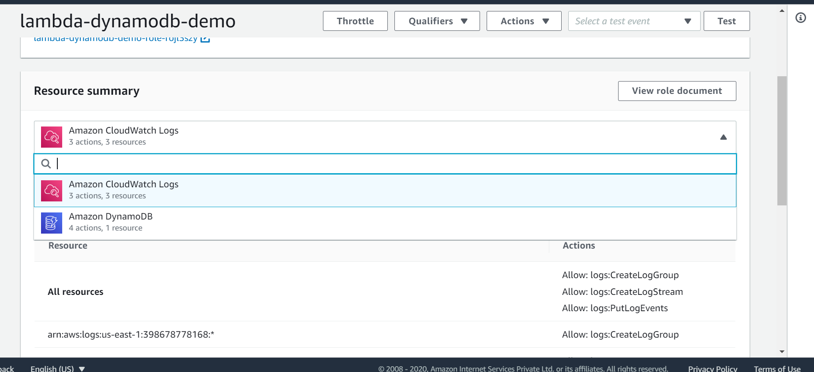

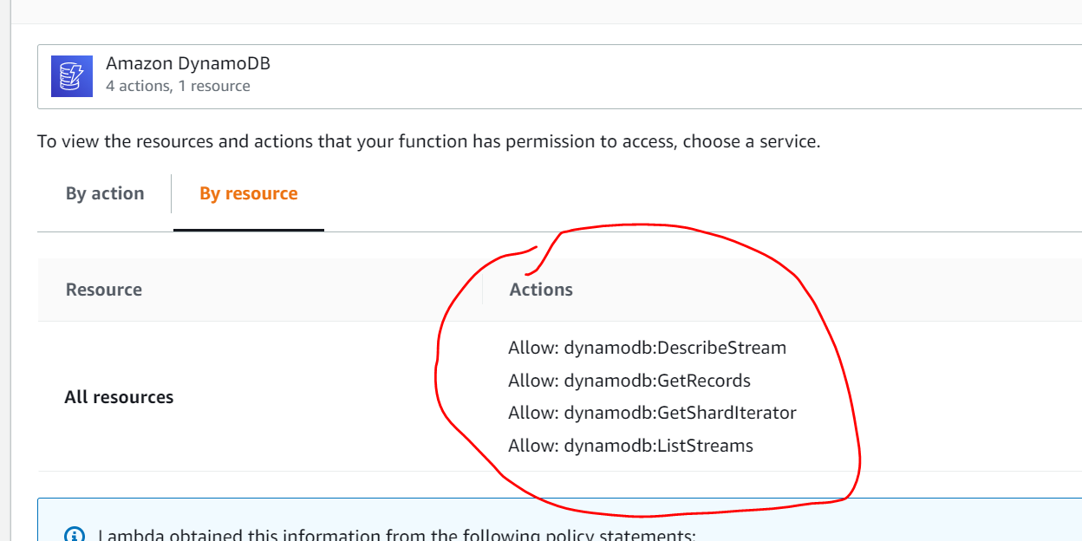

**Click on trigger and add dynamodb**

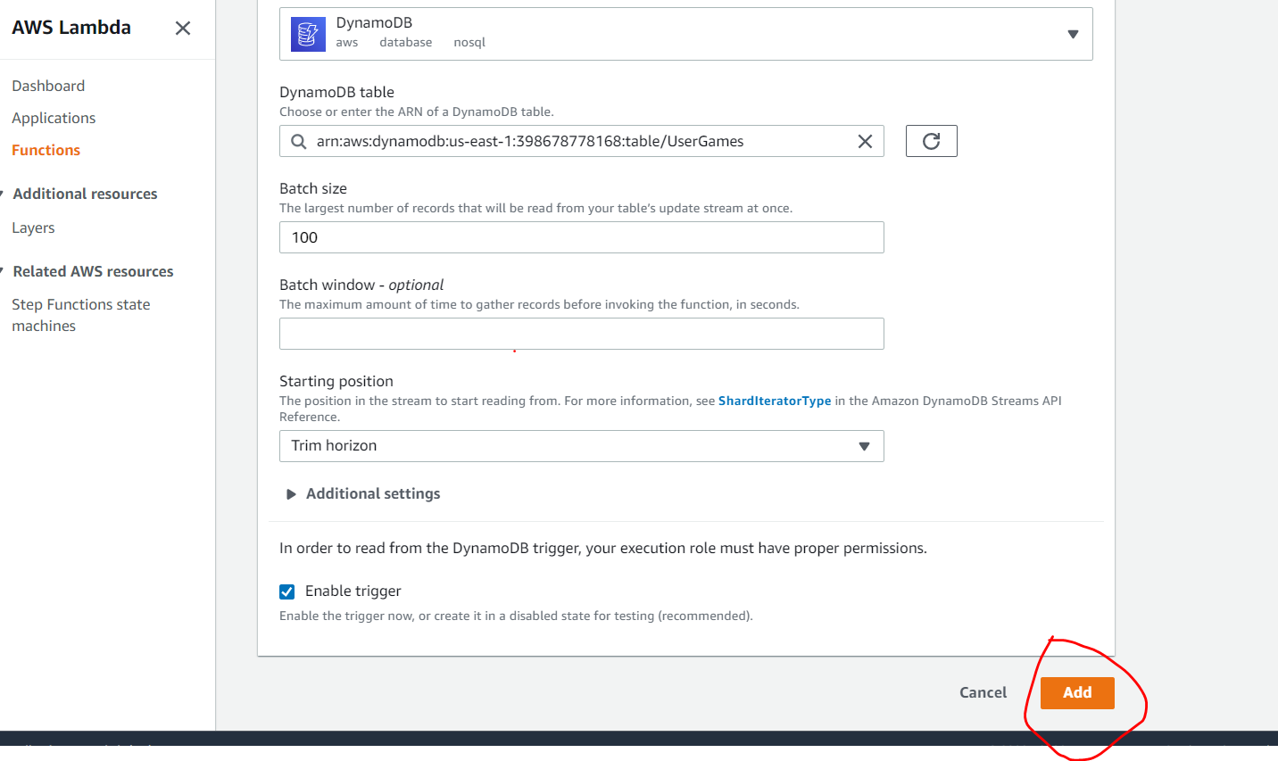

**Click on add**

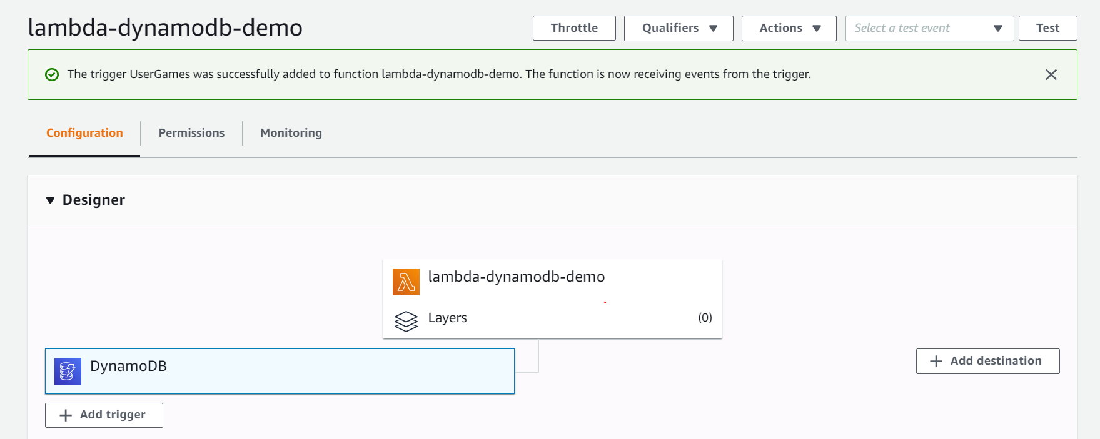

**No record processed because even table has one item but we created stream after that so item will not processed it**

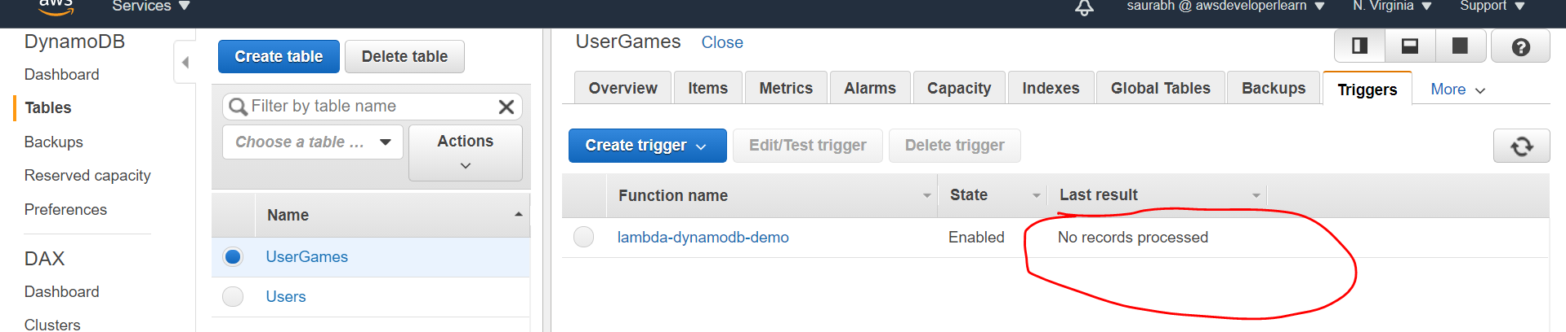

**Create a new item and delete previous one**

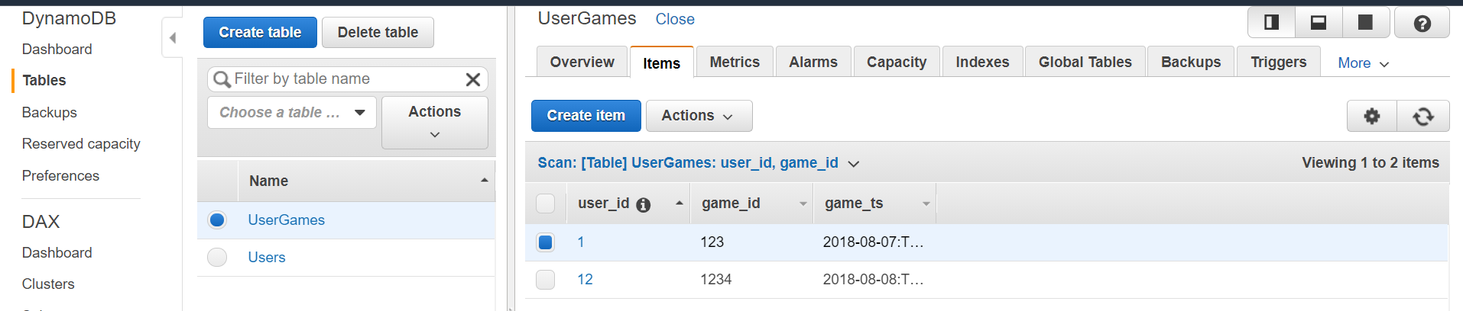

**Delete 1 record**

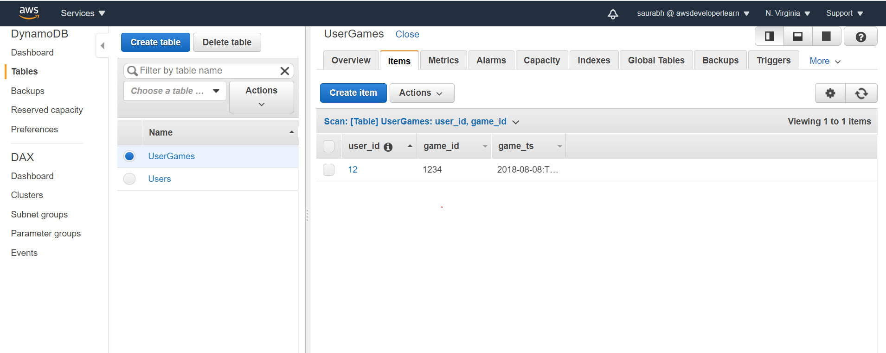

**Trigger ok means some result processed by lambda function**

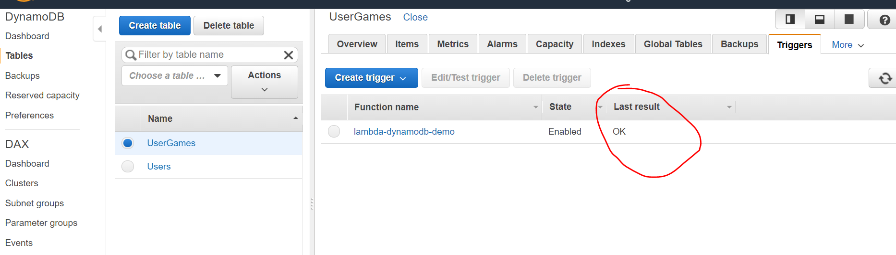

**Go to cloudwatch and check it**

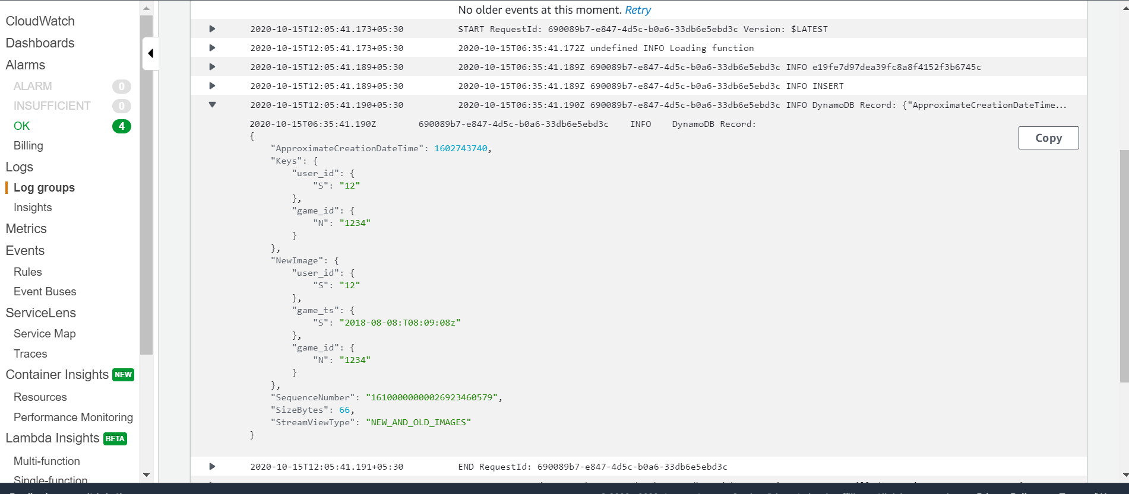

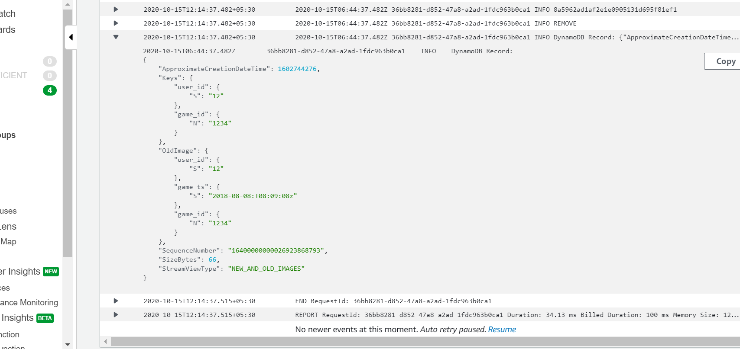

**Disable trigger**

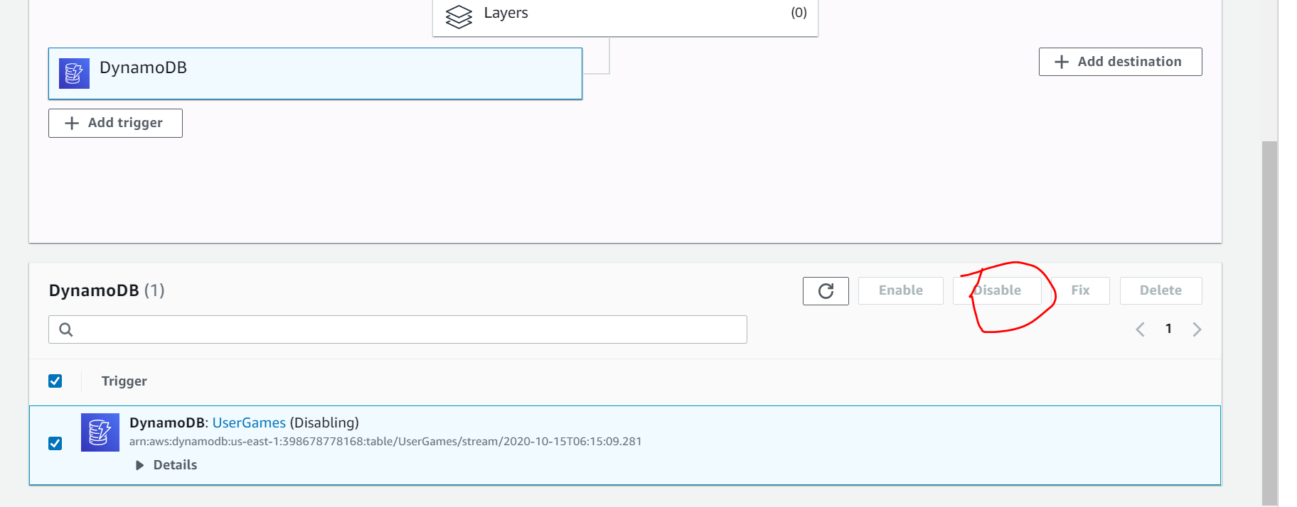

**DynamoDB TTL( time to live)( free)**

**Define a column and expiry time and after that much of time it will get expire**

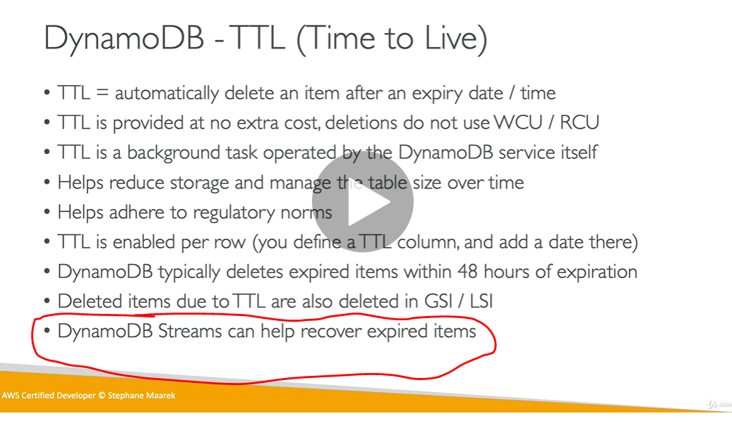

**TTL hands on**

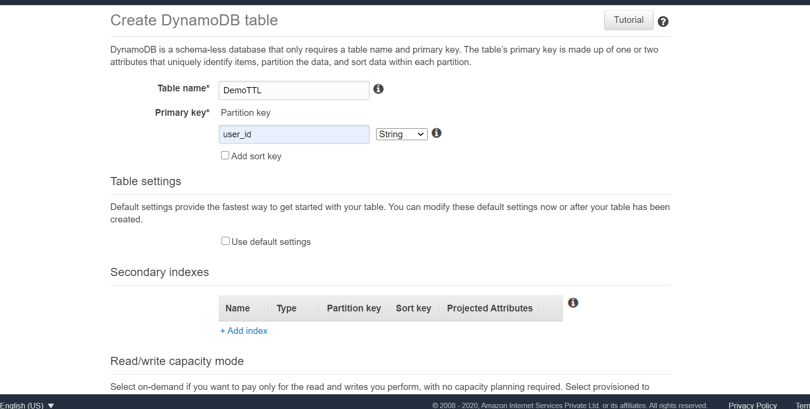

**Click create**

**Click time to epoc in google**

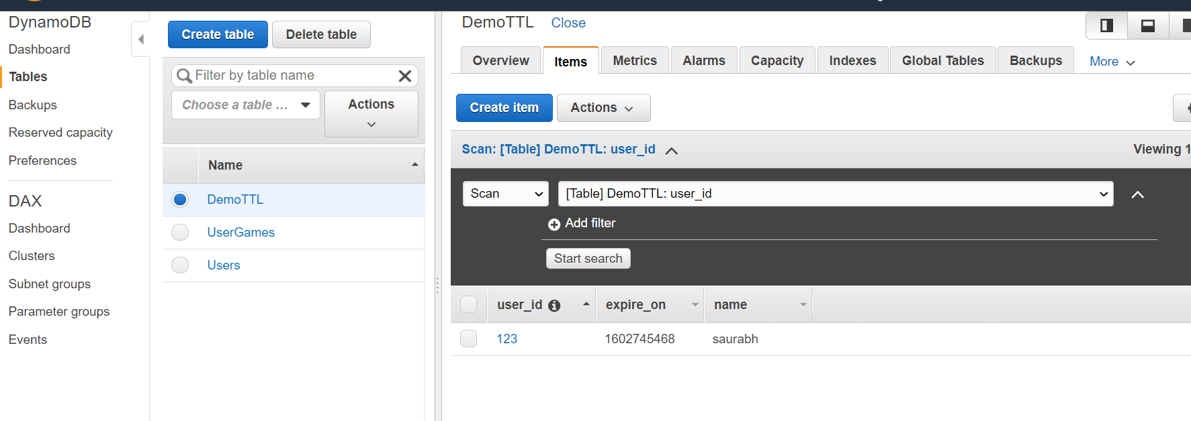

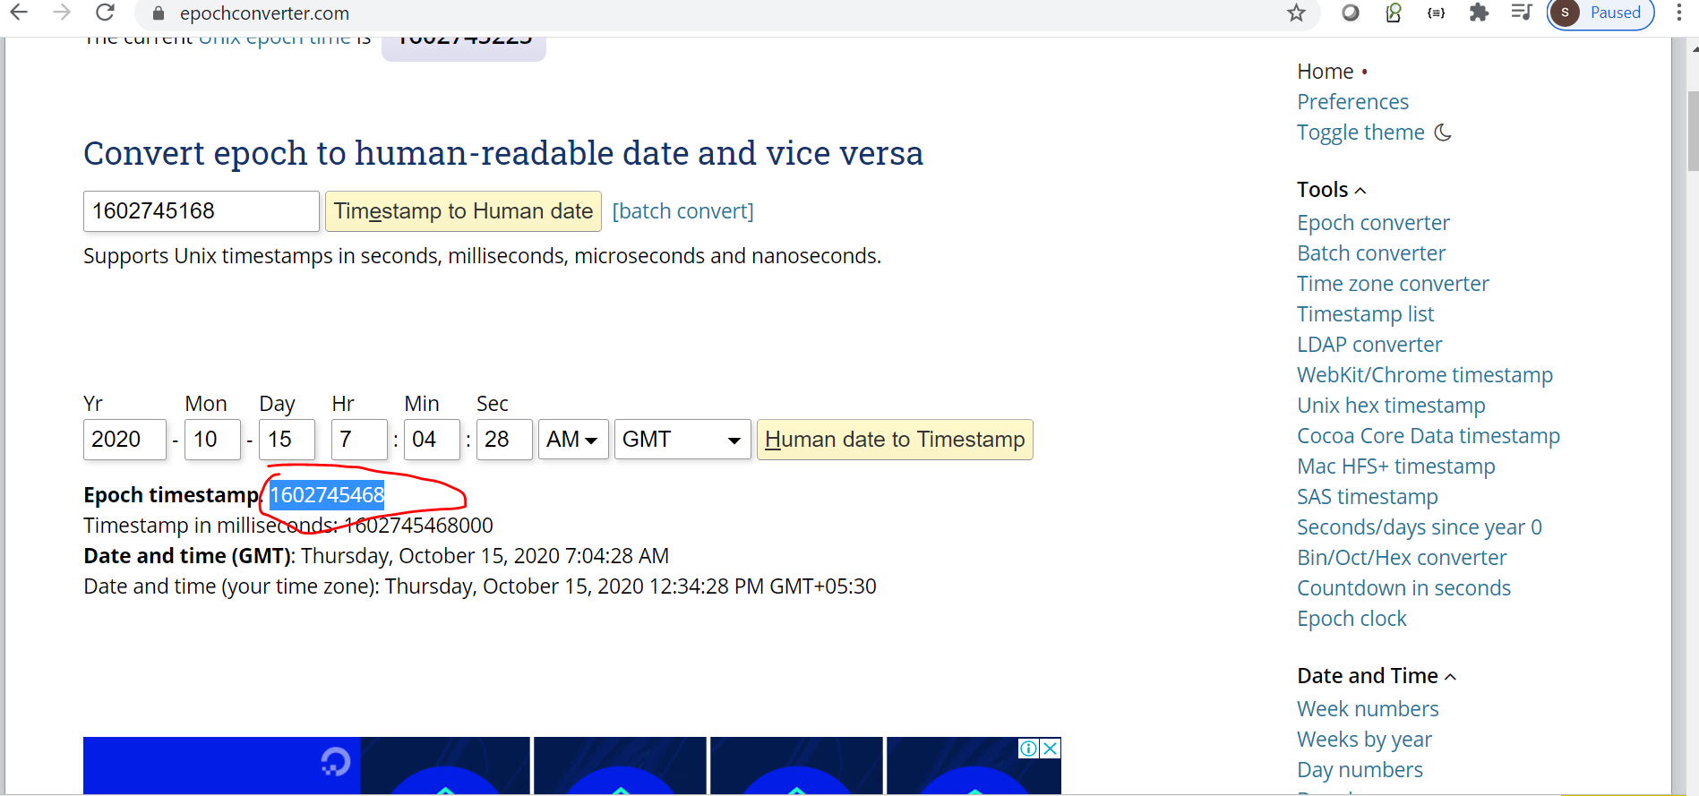

**Click on manage_ttl**

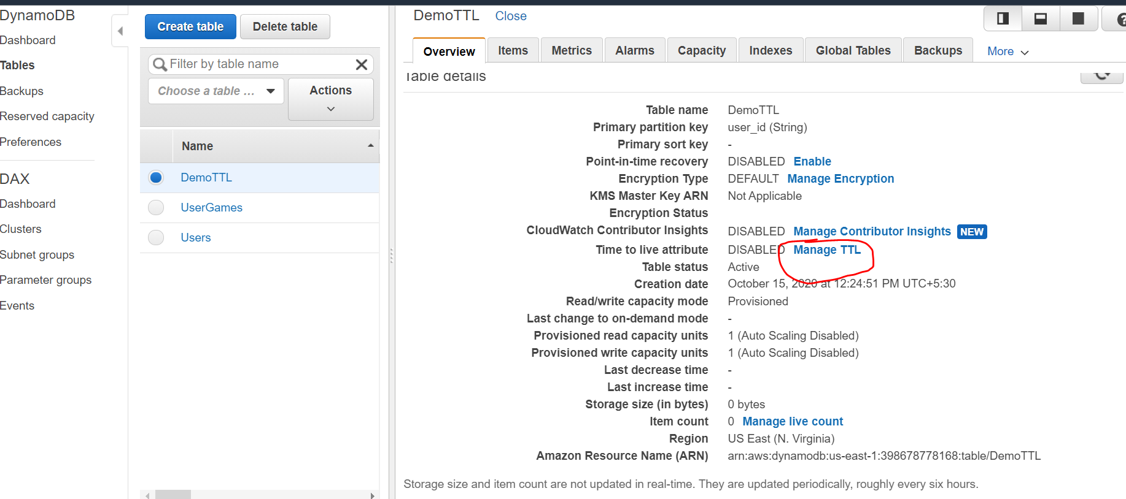

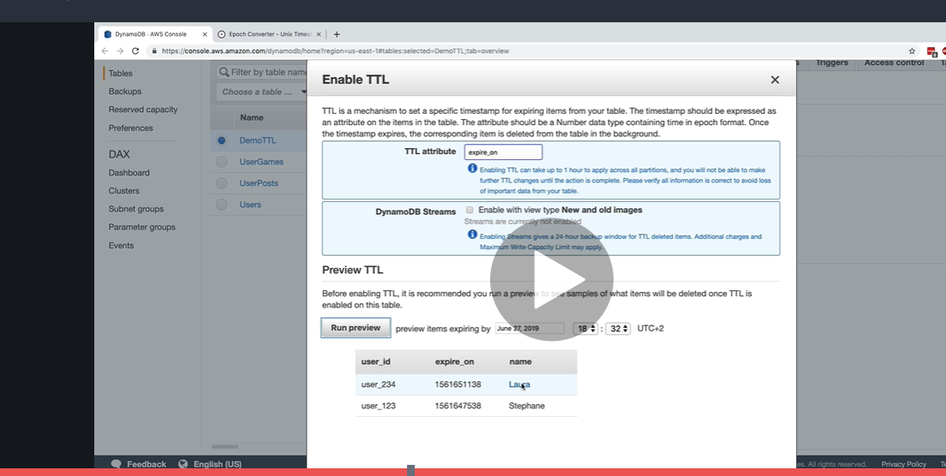

**DynamoDB cli**

**Page-size: more api call can be done but probably will return smaller data**

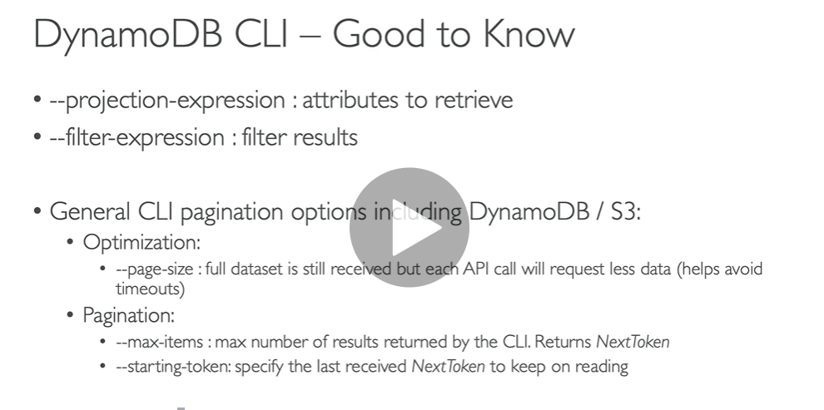

**Hands on**

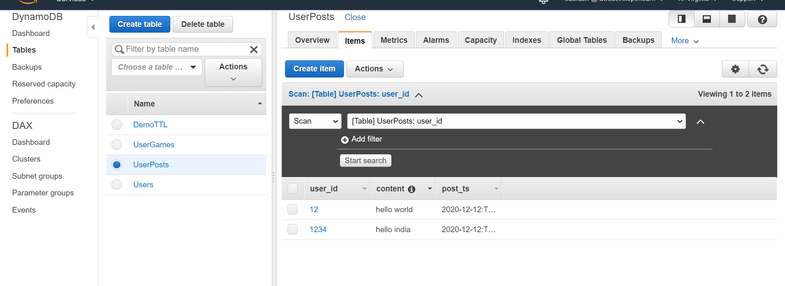

**Projection -expression : whatever column we want only that it will return**

#!/bin/bash

# Demo Projection Expression

aws dynamodb scan --table-name UserPosts --projection-expression "user_id, content" --region us-east-1

# Demo Filter Expression

aws dynamodb scan --table-name UserPosts --filter-expression "user_id = :u" --expression-attribute-values '{":u": {"S":"s12"}}' --region us-east-1

# Page Size demo: will do 1 API call if you have 3 Items

aws dynamodb scan --table-name UserPosts --region us-east-1

# Will do 3 API calls if you have 3 Items

aws dynamodb scan --table-name UserPosts --region us-east-1 --page-size 1

# Max Item demo:

aws dynamodb scan --table-name UserPosts --region us-east-1 --max-items 1

# Fetch the next item

aws dynamodb scan --table-name UserPosts --region us-east-1 --max-items 1 --starting-token eyJFeGNsdXNpdmVTdGFydEtleSI6IG51bGwsICJib3RvX3RydW5jYXRlX2Ftb3VudCI6IDF9

# Fetch the next item

aws dynamodb scan --table-name UserPosts --region us-east-1 --max-items 1 --starting-token eyJFeGNsdXNpdmVTdGFydEtleSI6IG51bGwsICJib3RvX3RydW5jYXRlX2Ftb3VudCI6IDJ9

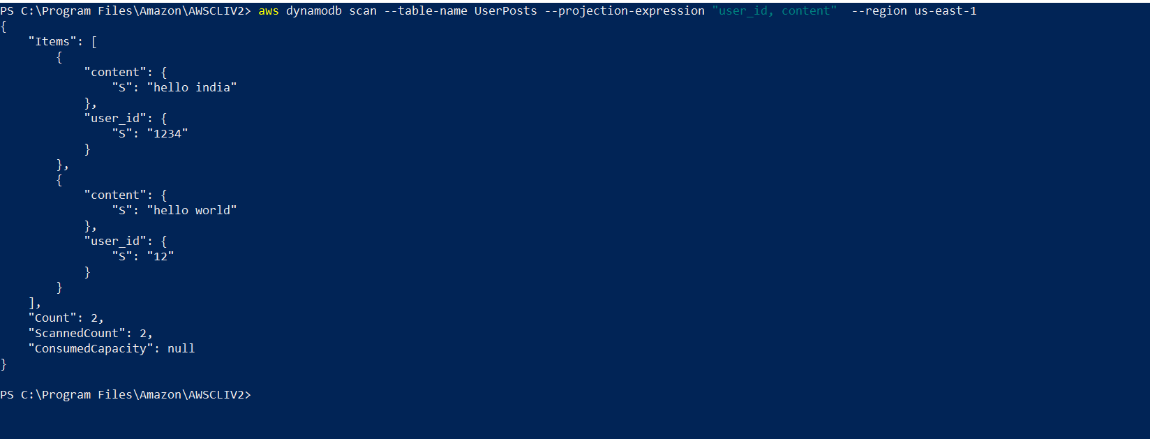

**We are getting next token which we can use it to find next item**

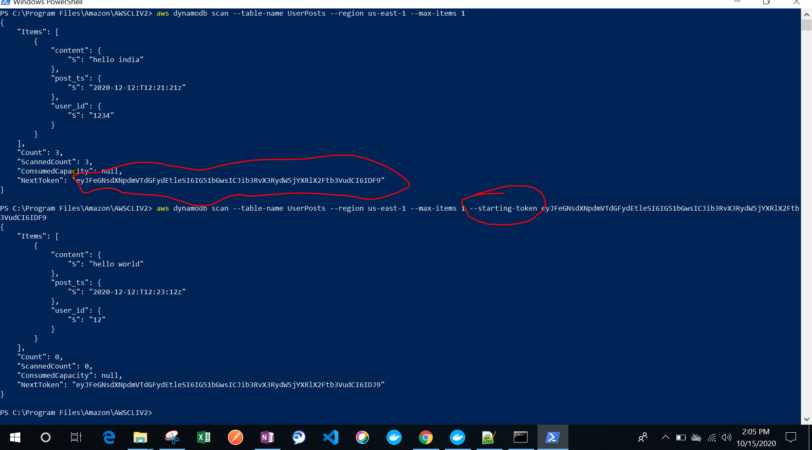

**DynamoDB transaction**

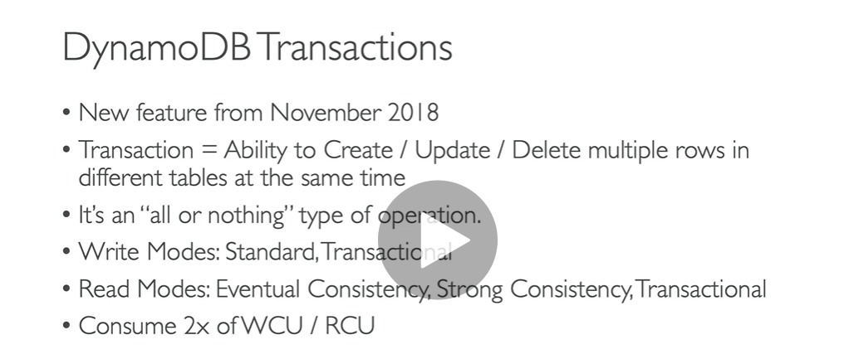

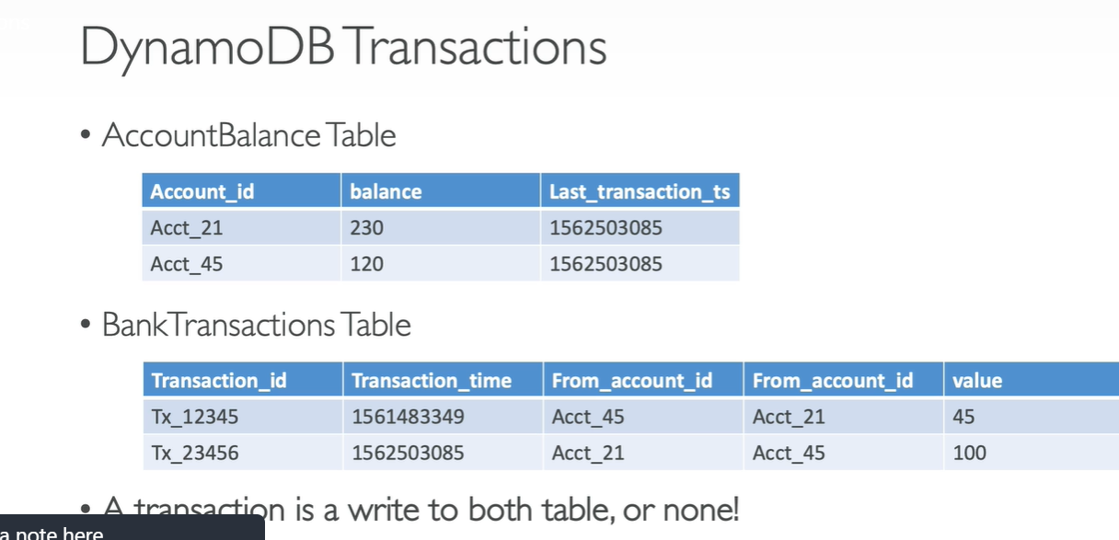

**DynamoDB Session state**

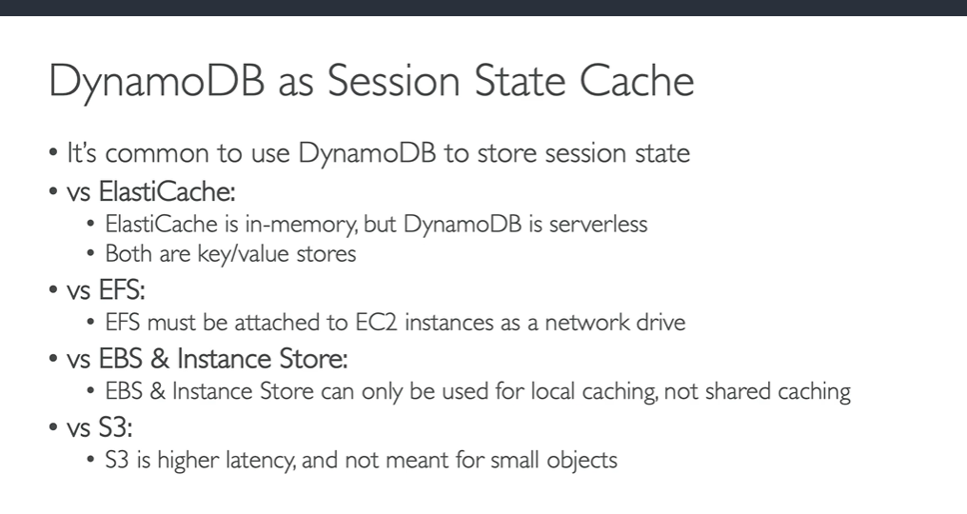

**DynamoDB partitioning startegies**

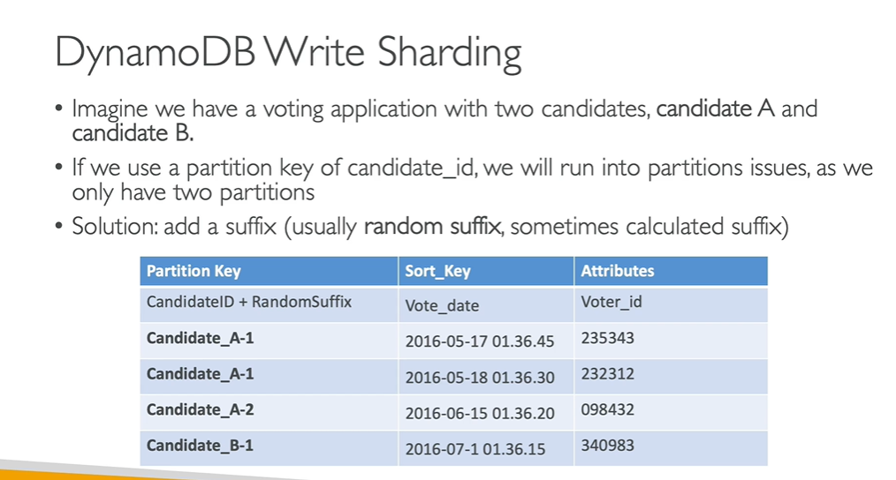

**DynamoDB conditional writes , concurrent writes and atomic writes**

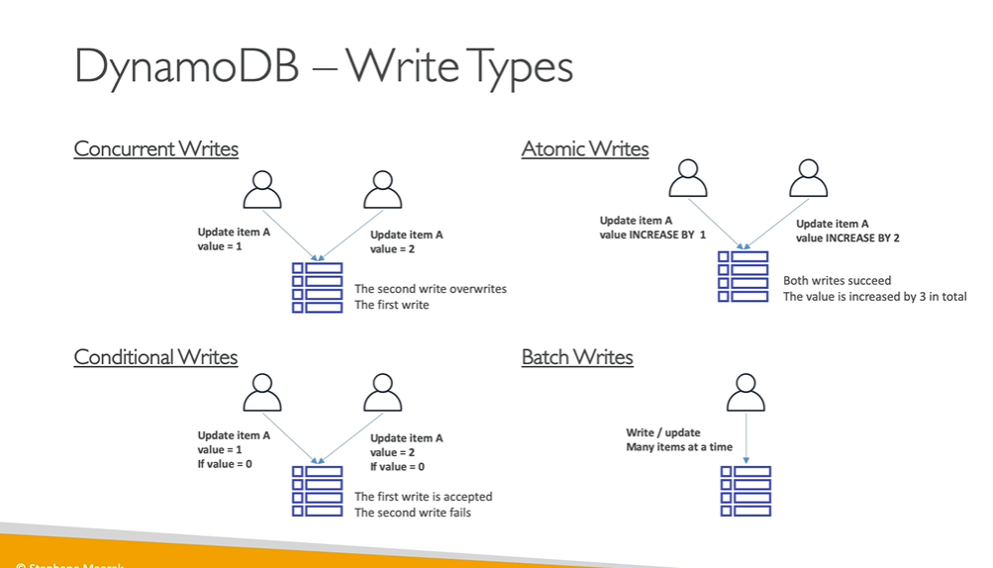

**DynamoDB pattern with S3**

**Note : not recommended to store large object in dynamo db**

**But what if we want to store large object in DynamoDB**

**First way : think dynamo db will point to s3**

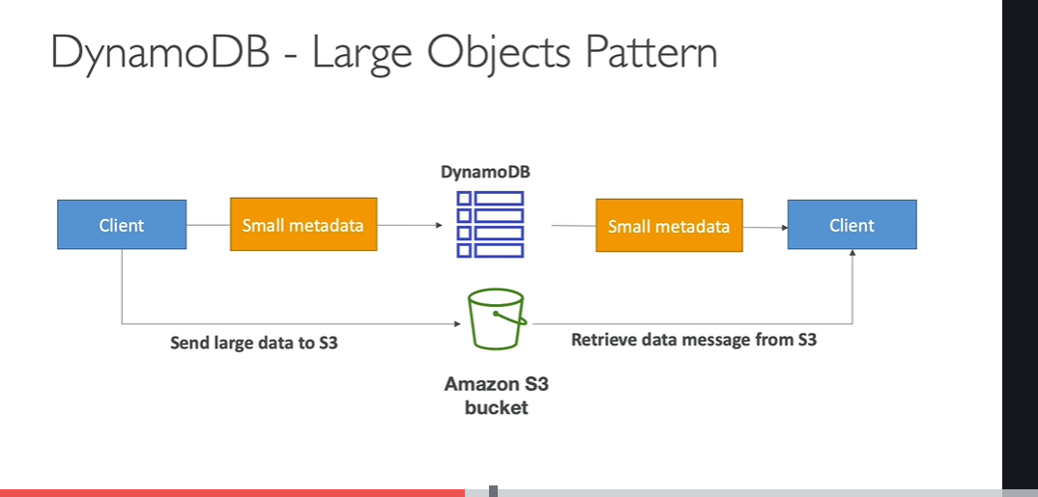

**Second way : lambda function will take metadata from s3 and store in DynamoDB table because in dynamodb table it more easy to search and indexing**

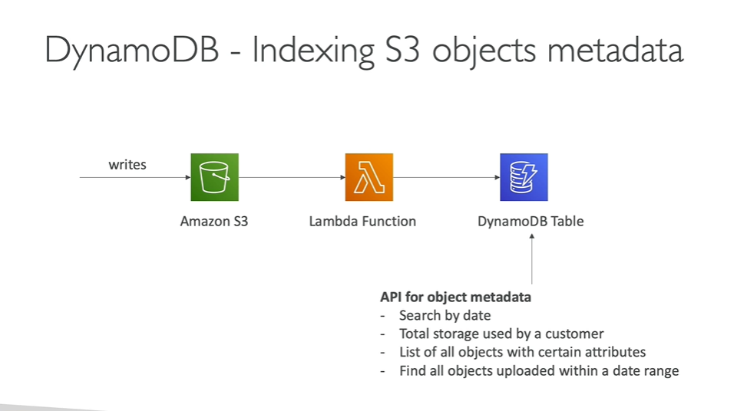

**DynamoDB operations**

**Copy dynamodb table ) copy into s3 and back put it into dynamodb table**

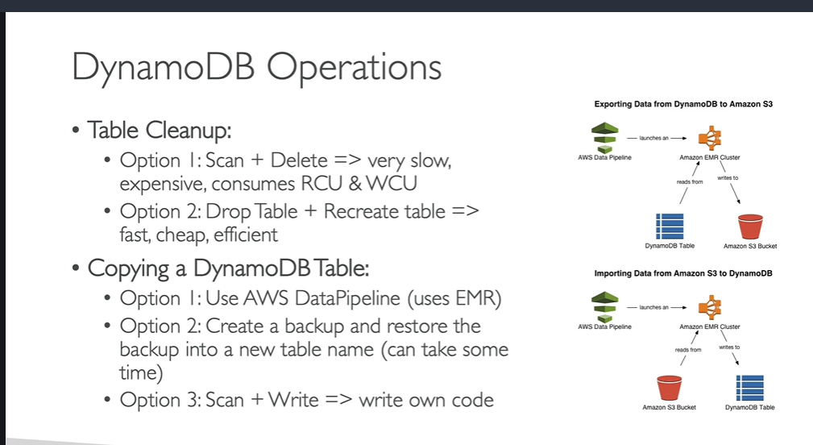

**DynamoDB security and other**

